**H2O.ai Driverless AI**

**Introductory Lab Guide:**

**Getting Started with  
Automated Machine Learning**

AI Center of Competency

[aicoc@us.ibm.com](mailto:aicoc@us.ibm.com)   
IBM Systems Client Experience Center  
May 1st , 2020

**Table of Contents**

1. Introduction 3

2. Prerequisites 4

3. Important Notes 4

4. Lab Steps for Client Credit Card Use Case 5

LOGIN 5

PREPARE DATASET 7

VISUALIZE DATA 11

SETUP EXPERIMENT 14

RUN EXPERIMENT 19

TEST MODEL 22

INTERPRET MODEL 23

EXPLORE NEW EXPERIMENTS 29

5. Using DAI to gain New Insights (optional) 33

Kidney Transplant Graft Rejection 33

Number of COVID-19 cases 33

6. Additional Resources 35

Appendix A: Requesting an H2O.ai Driverless AI Server from the CECC 35

**IBMers & BPs:** See Appendix A for instructions on requesting an IBM H2O.ai Driverless AI server.

# Introduction

H2O.ai is a Silicon Valley open source software company in AI and machine learning with a mission to democratize AI for everyone.

H2O.ai Driverless AI is an artificial intelligence platform for automatic machine learning (ML). It automates many of the most difficult machine learning workflows such as feature engineering and the selection, validation, tuning and deployment of ML models.

By using end-to-end automation, Driverless AI achieves the high predictive accuracies comparable to expert data scientists. It also offers built-in visualization and interpretability which are critical to understanding, explaining transparent models. Accurate models are exportable to Python and Java-based modules to provide scoring services.

While Driverless AI supports a variety of hardware, it has been optimized to take advantage of graphical processing units (GPUs) supported by IBM’s POWER9 AC922 server.

**Why H2O Driverless AI?**

H2O.ai Driverless AI employs the techniques of expert data scientists (e.g. Kaggle Masters) in an easy to use application that helps scale your data science efforts. Driverless AI empowers data scientists to work on projects faster using automation and state-of-the-art computing power from GPUs to accomplish tasks in minutes that used to take months.

With Driverless AI, everyone including expert and junior data scientists, domain scientists, and data engineers can develop trusted machine learning models. This next-generation automatic machine learning platform delivers unique and advanced functionality for data visualization, feature engineering, model interpretability and low-latency deployment.

For more information H2O please see their website:

<https://www.h2o.ai/>

This hands-on lab has been designed to give you the experience needed to be able to effectively demonstrate the core capabilities of H2O.ai Driverless AI (DAI) on Power Systems. Given the broad range of capabilities in DAI and because the dataset is structured data ( in the form of a spreadsheet), this lab will be focused on visualization of the data, feature exploration, machine learning models and the ability to interpret the results of the model.

A very simple, easily accessible dataset with be used for the use case for this hands-on lab. This dataset contains information on default payments, demographic factors, credit data, history of payment, and bill statements of credit card clients in Taiwan from April 2005 to September 2005. This window of information will be used to describe patterns and explore insights from credit card clients.

This type of financial analysis is a particularly interesting and compelling use case for DAI in the Financial sector. For example, determining if credit card clients are likely to default on a payment, or gaining insights on qualification for a loan approval or detecting fraud are all common historical structured data use cases in this segment. But the same techniques demonstrated in this lab can apply across all other segments of the market and with time.

We’ve included optional healthcare examples to try: a kidney transplant rejection prediction use case and a time series use case base on 2020 COVID-19 pandemic data.

The remainder of the guide is based on these use cases. However, given the seemingly limitless amount of structured data available, **feel free to use your imagination to devise your own use case with whatever data you have available**. The steps below all still apply.

# Prerequisites

1. Access to an H2O.ai Driverless AI instance (version 1.8, or later)
   * **IBMers and Business Partners can request access to an instance of H2O Driverless AI.** See Appendix A for instructions on how to request access.
   * **Customers can request a trial instance through an IBM Systems Client Center request.** See Appendix A for instructions on how to request access.
2. PC or laptop with connectivity to the Internet to download datasets or interest.

This is not needed if datasets have been pre-loaded.

1. Connectivity between your PC or laptop to the H2O.ai Driverless AI instance.
   * A VPN may be necessary on your device if the server resides behind a firewall. This is not needed if server is publicly accessible.

# Important Notes

* This lab was most recently tested with H2O.ai Driverless AI 1.8.4.1. Where important, differences from previous versions will be called out in the guide.
* Generally speaking, the H2O.ai Driverless AI interfaces may change over time, which means that what you see may not look exactly like the screen shots shown in this guide. Likewise, what is displayed on your PC or laptop may look slightly different, due to the differences in the display dimensions and how they each show windows and menus. Also, your device’s display settings will impact this as well.
* **Do not use any hostnames, IP addresses, usernames, or passwords mentioned in this guide. They are for example purposes only.** They will not work for you. Use what has been provided to you by instructors or what you have provisioned yourself.
* If you are sharing the H2O.ai Driverless AI server with other people doing this lab, whenever you create a new data set or model include your name (or team number) in its name to avoid conflicts. For example, if the instructions say to create a data set called “client records” then create it with the name “Team 1 client records” instead.

# Lab Steps for Client Credit Card Use Case

To start the lab, follow the instructions for the 15 steps below. You can keep track of your progress by checking off each step when completed.

## LOGIN

Browse to H2O.ai Driverless AI Login Page (**HTTP** not HTTPS)

If you are using a CECC reservation, your kit will include a custom link like this:

To access the H2O.ai user interface, open a web browser and navigate to:

[http://p1242-kvm1.cecc.ihost.com:12345](http://p1242-kvm1.cecc.ihost.com:12345/) 🡨 example only, your link is different

Otherwise, get the assigned instance link from your instructor.

Accept H2O.ai license on the first visit.

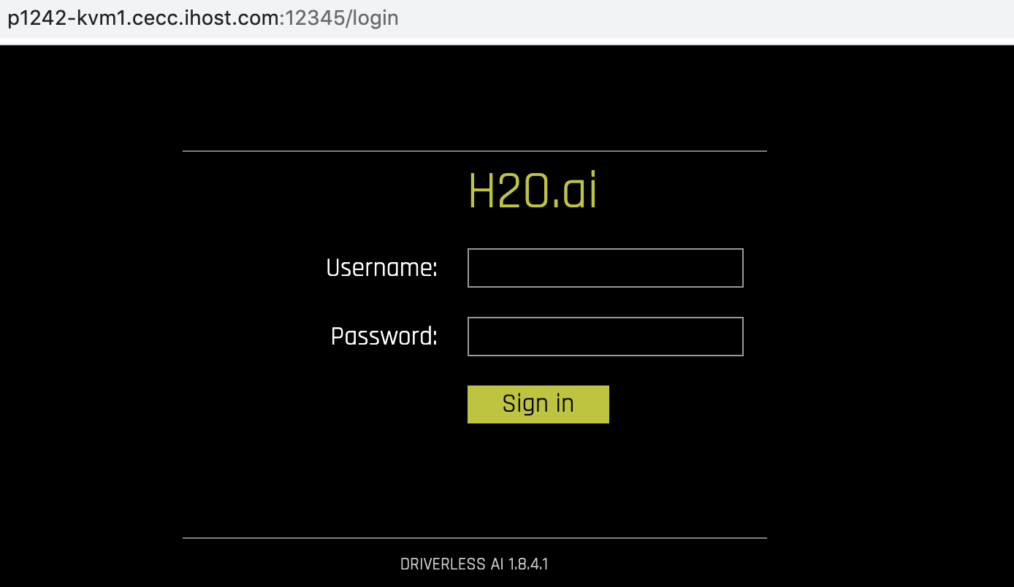

Log in to Driverless AI server

Enter the assigned or following default username and password to log in:

Username: dai

Password: dai

Explore top menu

We will not go through all of the top menu choices in this lab, but will list their meanings here:

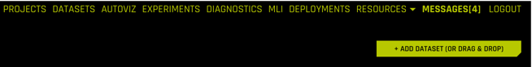

PROJECTS – Managing and grouping Datasets together with Experiments in one place

DATASETS – View the source datasets available and datasets that have been imported

AUTOVIZ – Navigate to the visualizations list page

EXPERIMENTS – Datasets we have used to generate predictions. We can have multiple experiments on a single dataset

DIAGNOSTICS – Ability to diagnose a model against a different dataset

MLI – Machine Learning Interpretability – Explains the model results in human readable format

DEPLOYMENTS – tracks deployed models

RESOURCES – select pull-down tab to see the following:

SYSTEM INFO – information about the server (# CPUs, #GPU, memory, disk space)

PYTHON CLIENT – This will download a binary file associated with running a generated Python Scoring Pipeline for an experiment. We will discuss this later.

R CLIENT – This will download a binary file associated with running a generated Python Scoring Pipeline for an experiment. We will discuss this later.

MOJO2 JAVA RUNTIME – This will download a binary file associated with running a MOJO Scoring Pipeline. MOJO is an acronym for a Java object model. We will discuss this later.

MOJO2 PYTHON RUNTIME – This will download a binary file associated with running a PYTHON variant MOJO Scoring Pipeline.

MOJO2 R RUNTIME – This will download a binary file associated with running an R variant MOJO Scoring Pipeline.

HELP – Self descriptive. Links to docs including user guides.

MESSAGES – notifications and announcements

LOGOUT – logout and return to user login screen

+ADD DATASET (or Drag and Drop) – Allows the importation of a data set for processing. This is typically the starting point.

## PREPARE DATASET

Download lab dataset to your PC or Laptop

Note that this step is optional if your dataset is pre-loaded into H2O or if you have previously saved the dataset onto your PC or laptop by following pre-lab steps from your instructor.

Download dataset from Kaggle to laptop

<https://www.kaggle.com/uciml/default-of-credit-card-clients-dataset/data>

**Hint:** you’ll need to create a login ID for the Kaggle website if this is your first visit. The website is a popular resource for data scientists. It hosts a number of interesting datasets and use cases.

Alternatively, a copy of the dataset is also available from Box.

Download dataset from Box to laptop

<https://ibm.box.com/v/UCICreditCard-dataset>

Driverless AI uses tabular data, typically found in existing Comma-Separated Value (CSV) typically generated by spreadsheets which is the format we will be using in this lab.

Add dataset to H2O.ai Driverless AI framework

Note that this step is optional if dataset is pre-loaded and visible under DATASETS tab

Click “+ADD DATASET” and Click “FILE SYSTEM” if your file is already on the server per your instructor or “UPLOAD FILE” if your file is on your PC or Laptop from previous step.

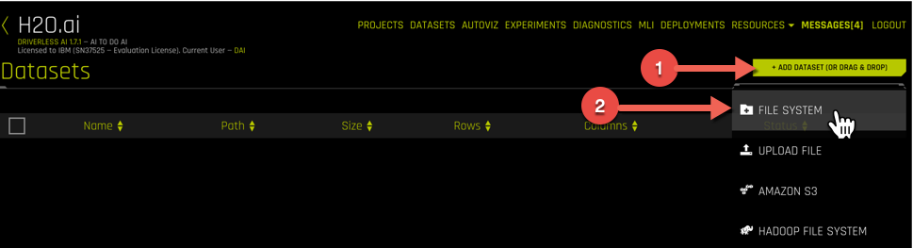

Find and open the folder where you saved the UCI_Credit_Card.csv file ( e.g. “data/” directory).

Note that if you are uploading the file, you will see different selection menus and prompts based on your PC or Laptop settings.

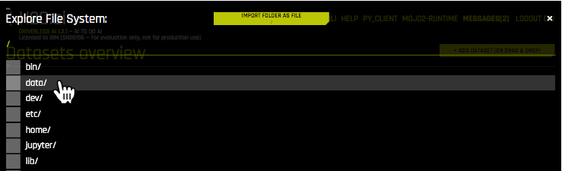

and select the “UCI_Credit_Card.csv” file and click import file or open to upload file.

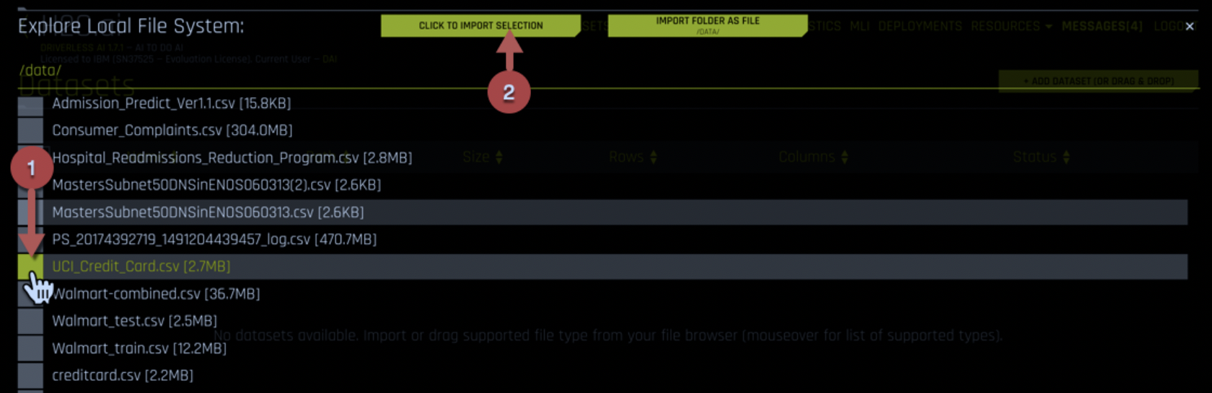

Explore dataset details and contents

Click on the UCI_Credit_Card.csv row and select “Details”

Note the columns listed for this experiment show 30000 Rows and 25 Columns of data.

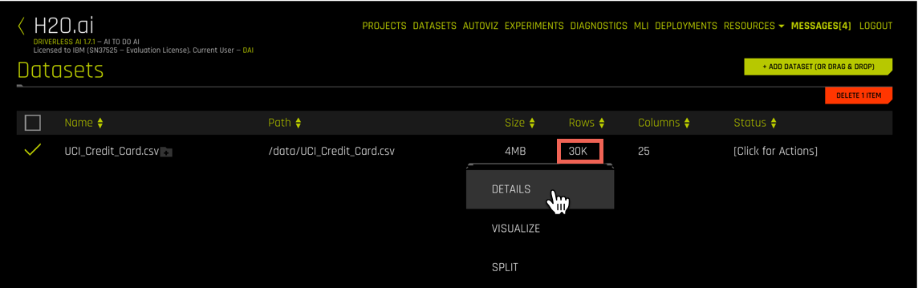

Click “Dataset Rows” to see a view of the row entries.

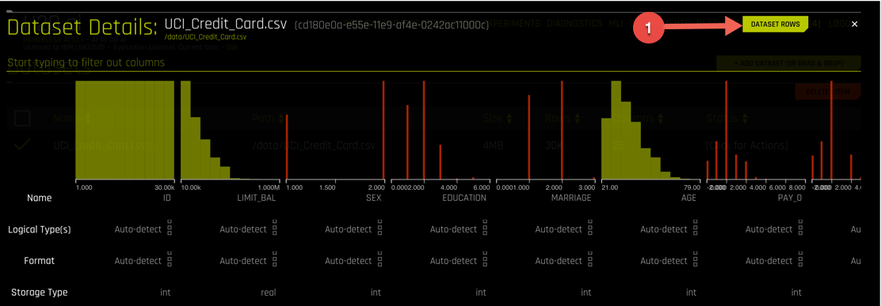

Use the bottom scroller to move left and right and view the data. The column titles represent the names of the columnar data within the dataset. You can also hover over the histogram graphs and a pop-up will show more details about each column.

Click the “Dataset Overview” button to return. The overview provides a formatted view of the contents of your CSV dataset.

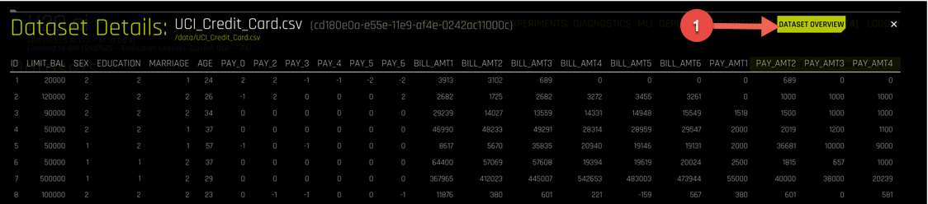

To filter on different columns to change the view (like Pay), simply enter the column of interest below “Dataset Details”.

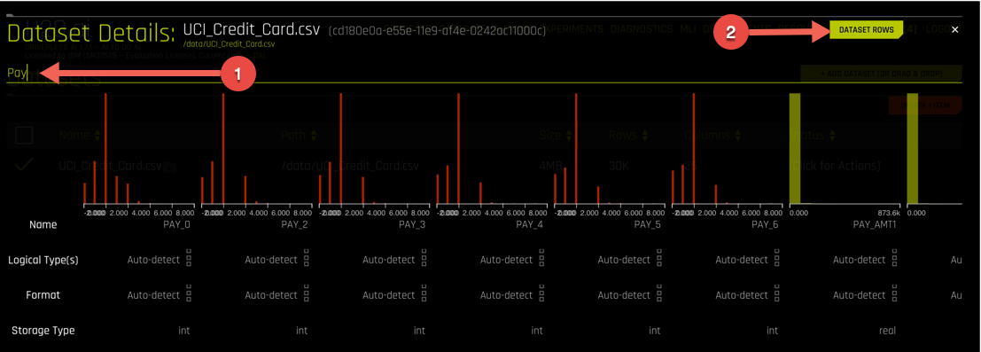

Example of filtering for “Education”. This field like many in data science products, the numeric values here map to specific meanings, e.g. high school, bachelors, masters or graduate degree.

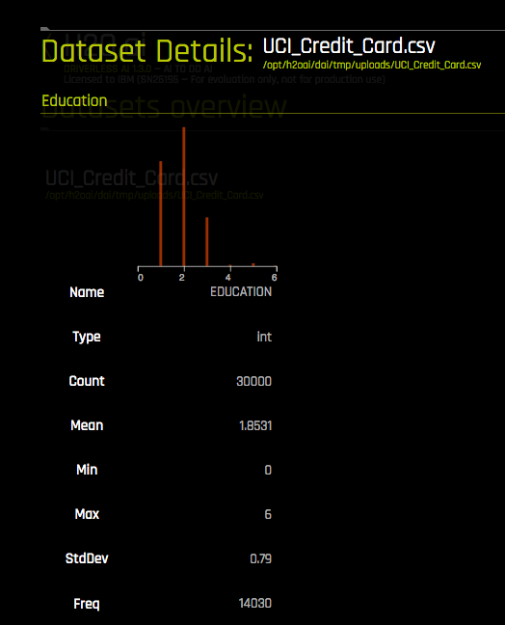

After you are done, close the view by hitting the ‘x’ to return to “DATASET OVERVIEW”.

Split the data into training and testing datasets

This is a best practice for data scientists to set aside a proportion of their data to test the model they build. The test dataset will not be used for training at all. DAI provides many options for how to split the data, we will do a simple 80/20 split.

Click the UCI_Credit_Card.csv row and select “SPLIT”

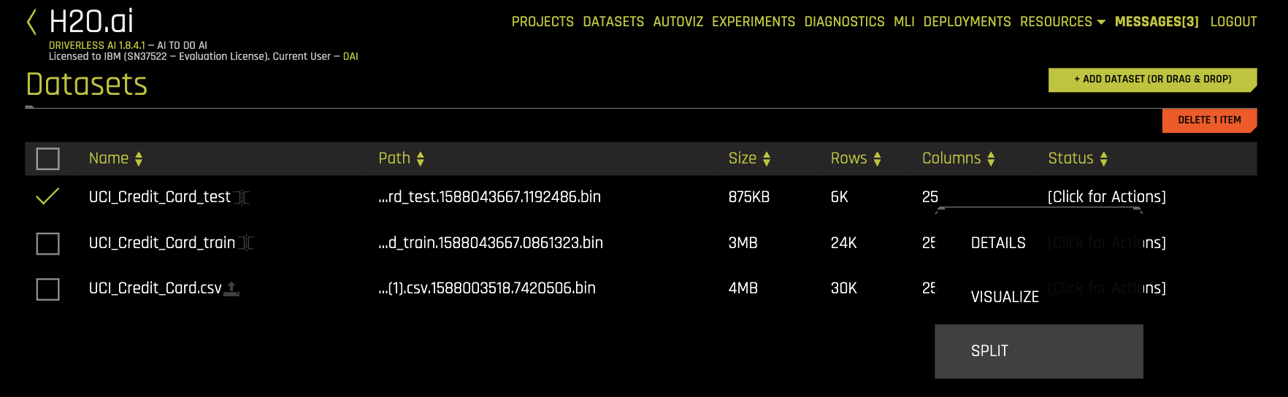

In the split dialog pop-up, input new names for the resulting split files (e.g. “OUTPUT NAME 1” is to UCI_Credit_Card_train.csv and “OUTPUT NAME 2” is set to UCI_Credit_Card_test.csv) and split ration (e.g. “SELECT SPLIT RATIO” is set to 0.8)

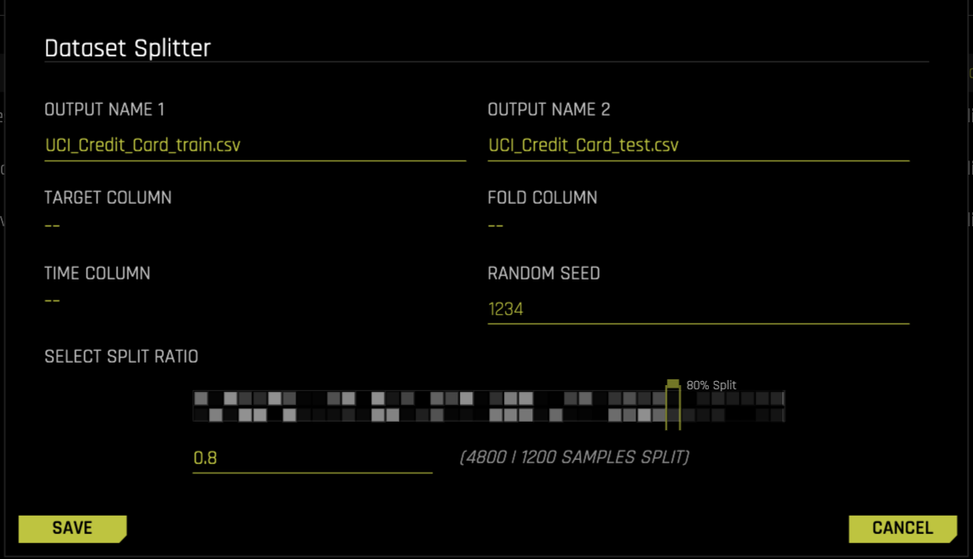

You now have created 2 new datasets that we will be using later for training and testing.

## VISUALIZE DATA

Visualize the data

Click on the original UCI_Credit_Card.csv row and select “VISUALIZE”

**Hint:** [Click for Actions] will let you see the drop down menu and open results as well.

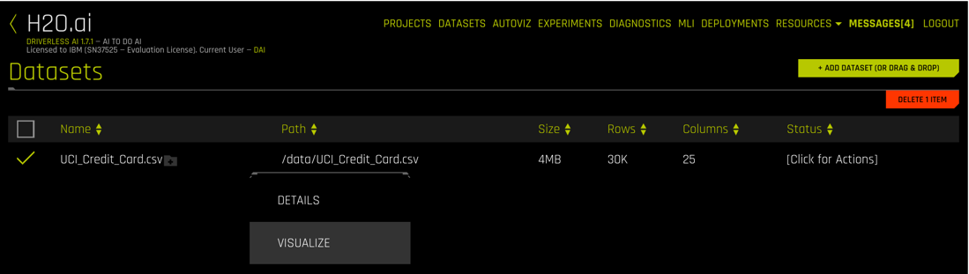

Explore the different visualization options available to you. Do you see any interesting relationships that jump out?

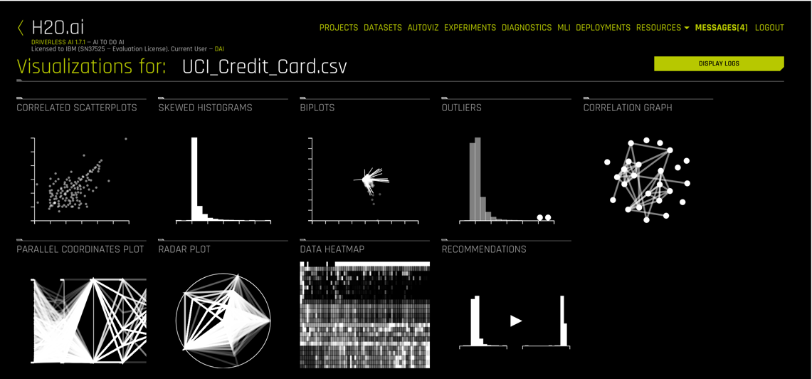

H2O Driverless AI automatically generates visualizations and creates data plots that are most relevant from a statistical perspective based on the most relevant data statistics to help users get a quick understanding of their data prior to starting the model building process. Depending on the dataset, different charts will be presented with visualizations of interest. You can also see recommendations for data transformations.

You can double-click on any graph, which will pop-up and also have choices for downloading or help. The help selection will give a general explanation of the plot type and how it is used by data engineers and scientists. Most users will be familiar with histograms and what we might be looking for there are spike or outlier values, which may be meaningful or perhaps a bad data value is present. For example, if we had a human age in years and one entry showed 255, it would point us back to fixing the dataset for an error.

Here is an example of the AGE values in the dataset as viewed by a Skewed Histogram on the left. We don’t have someone with an unusual age (no 2-year-olds with credit histories), but what we do see is that the data is somewhat spikey with respect to ages. In a normal population of consumers, we might expect something more like the distribution on the right. A data analyst would have to think about whether our dataset represents the population accurately or if people just tend to default at certain ages.

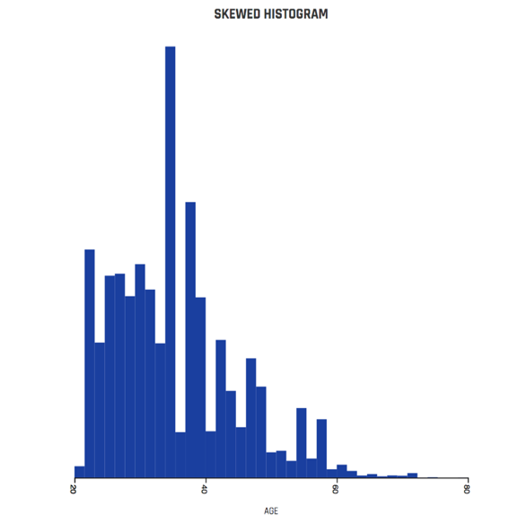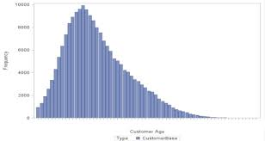

H2O Age Histogram Normal population distribution

Some generated graphs are interactive, like the Correlation Graph below, where you can grab one of fields (as dots) and move them around.

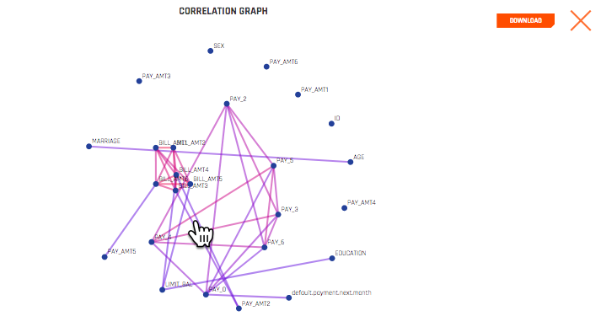

You can optionally repeat this visualization step for the split datasets you created. This can be useful to check that your train and test datasets have similar patterns.

Click “H2O.ai” to return to the Datasets page. Top menu “AUTOVIZ” lists all the visualization you have done so you can refer back to visualization results as needed.

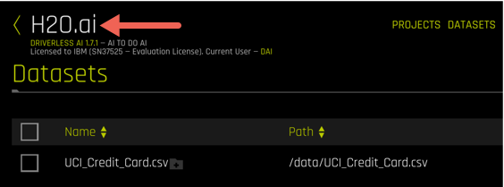

## SETUP EXPERIMENT

Set up experiments to make predictions

With a good understanding of our data we are now ready to get to the automated machine learning component of this lab.

Click the UCI_Credit_Card_train.csv row and select “PREDICT”

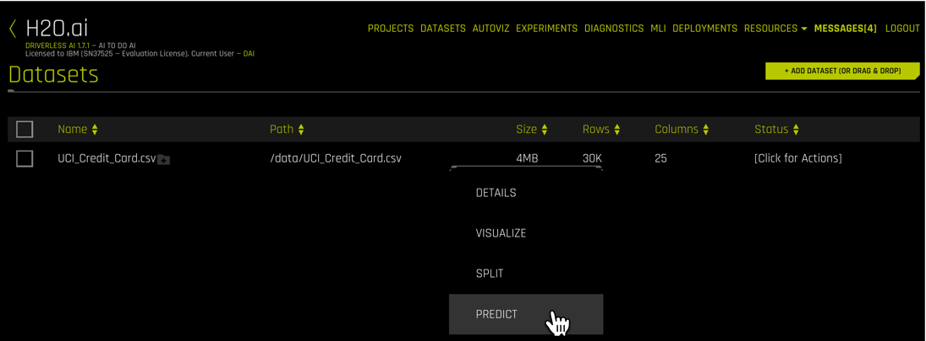

Walk through a brief 5-minute tour of the Prediction interface. We’ll be going through the tour steps

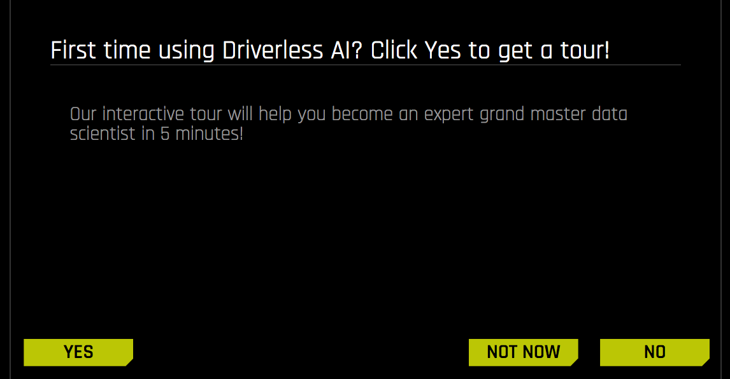

If this tour pop-up doesn’t show up, no worries. Go ahead and select “+NEW EXPERIMENT” and follow along:

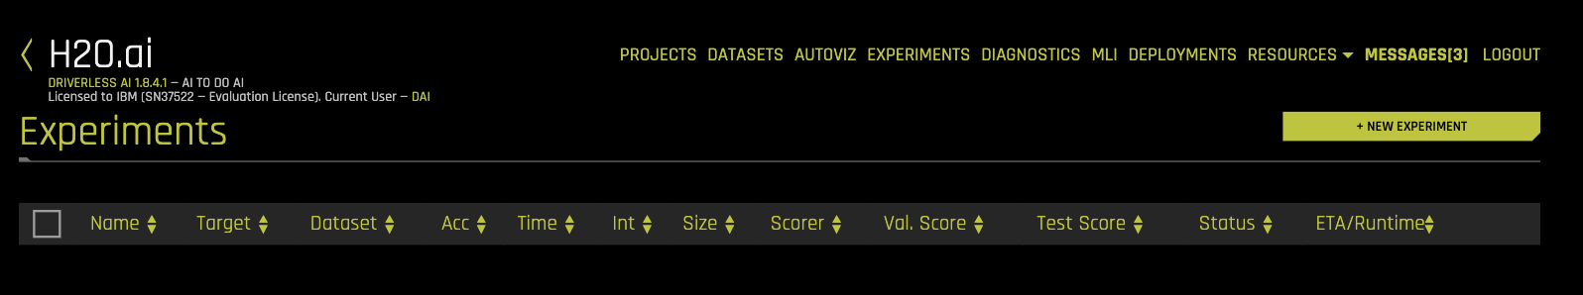

First choice in the tour is to show the selection of a dataset (“DATASET”), select NEXT when you want to proceed to the next tour menu

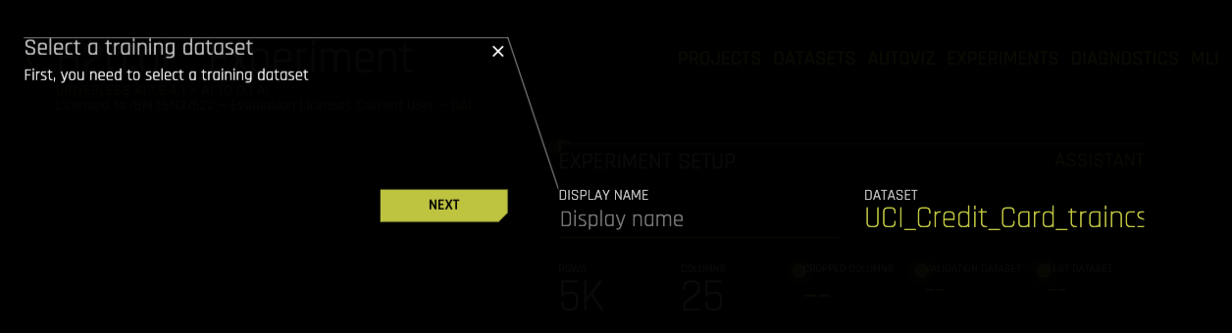

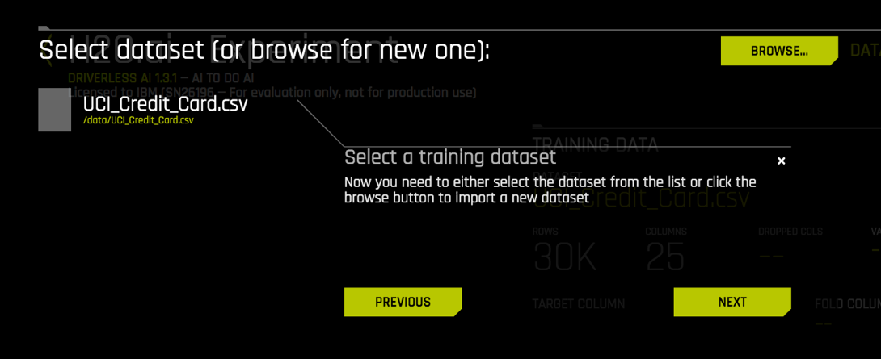

The next choice is to select a target column (“TARGET COLUMN”) to be **predict**. We would like to predict if the cardholder is going to default on next month’s payment. You may need to scroll down to see this option.

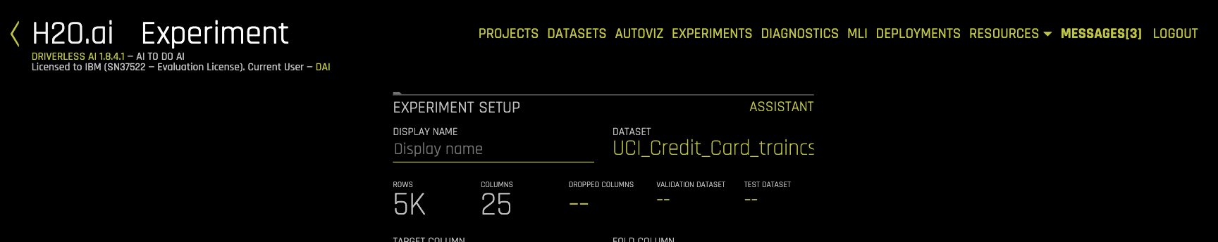

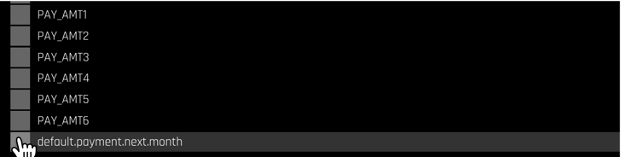

The next choice covers if the data has a dependency upon time, and the selection of the column to be treated as a time-series (“TIME COLUMN”)

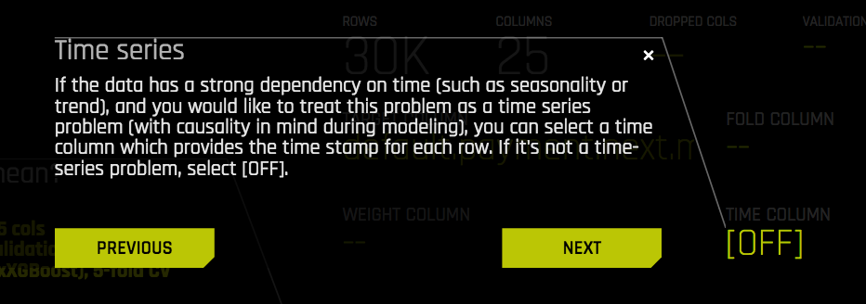

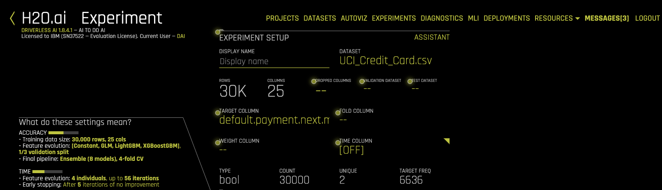

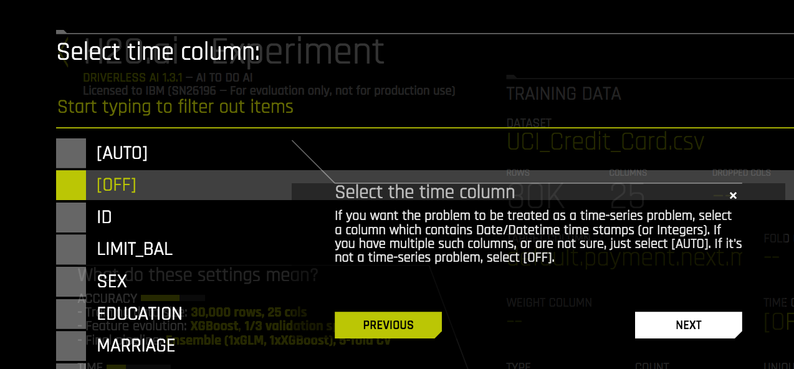

In the center of the interface, there are three primary dials for tuning.

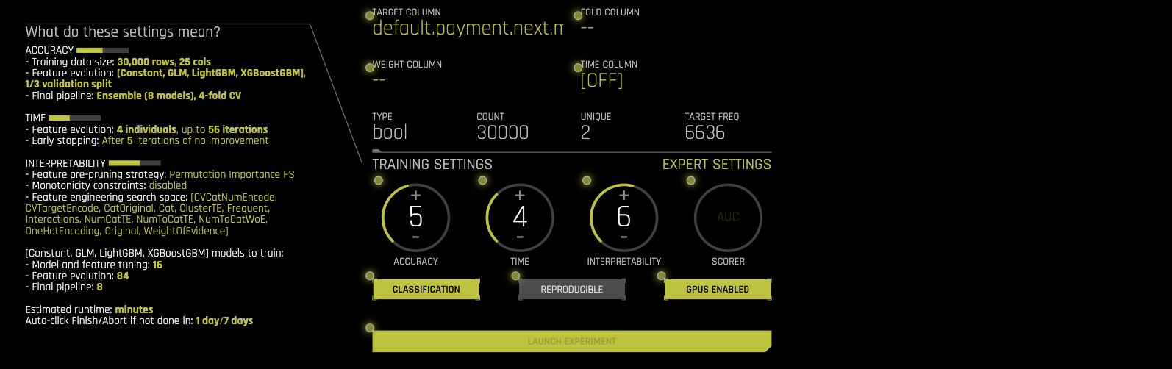

The first is an accuracy setting with a range from 1 to 10. The higher the number, the more accurate the model will be, but will also take more time to generate a model. Lower value runs faster but potentially less accurate.

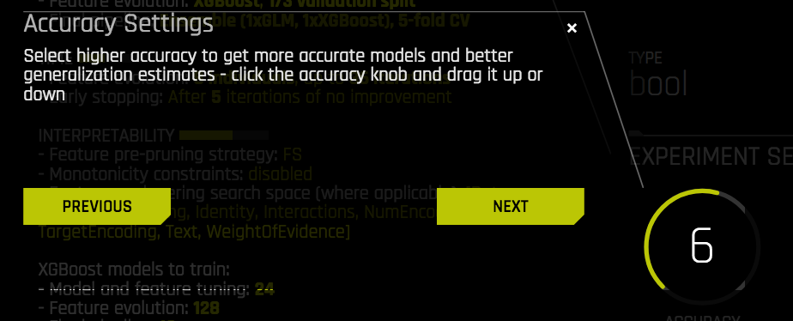

The second dial is the Time setting. This setting will determine how much time the training will run by controlling number of iterations and early stopping times.

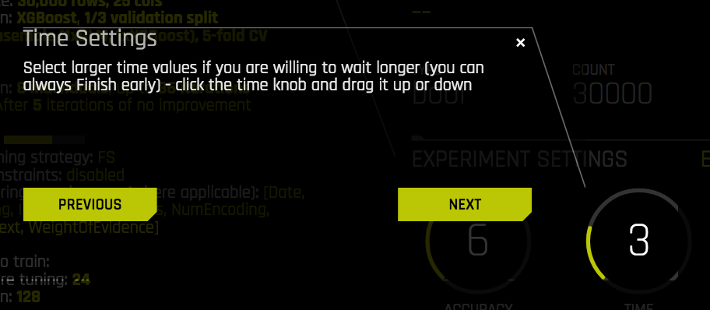

The third dial is the Interpretability setting. The higher the number, the more features will be used to generate the model. Lower values will have more complex models and more feature engineering.

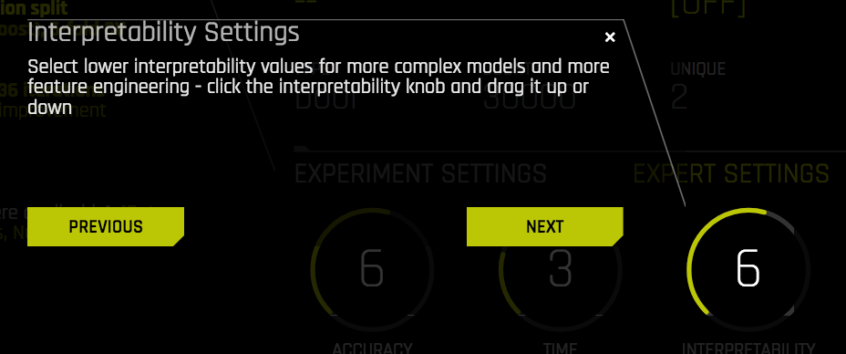

The fourth dial “SCORER” dial allows you to change the scoring selection. This is also automated depending upon analysis of the dataset and other selections, but advanced users can choose other options. AUC (Area Under the Curve) model metric was selected by default. AUC is used to evaluate how well a binary classification model is able to distinguish between true positives and false positives.

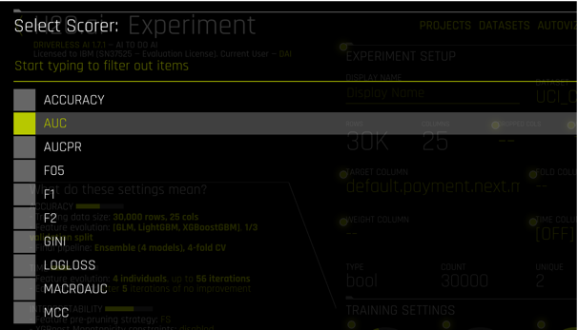

Refer to the following documentation webpage for a description of the available scores and best practices in selection the appropriate scorer for your experiment:

<http://docs.h2o.ai/driverless-ai/1-8-lts/docs/userguide/scorers.html>

## RUN EXPERIMENT

Launch experiment

You can now select the Launch Experiment and it will run in the background as you continue through the tour. If you aren’t running the tour, go ahead and launch experiment at the bottom of the main interface.



While an experiment is running, you will also note Performance Graphs and Tracing outputs being updated on the main interface

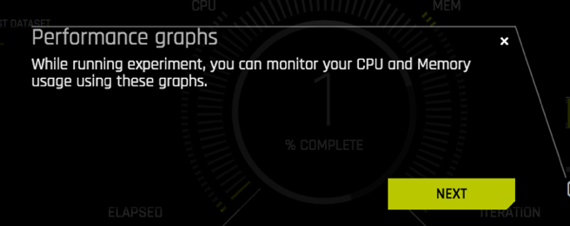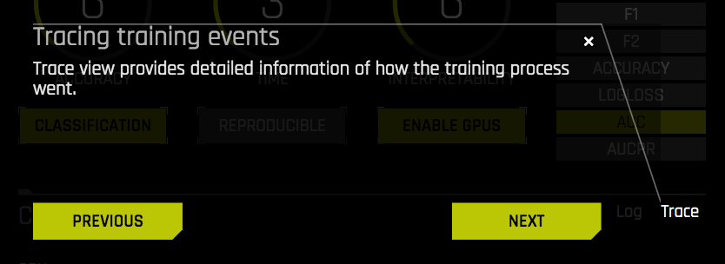

As the experiment runs, a progress graph shows the results as the model applies features and iterates through them

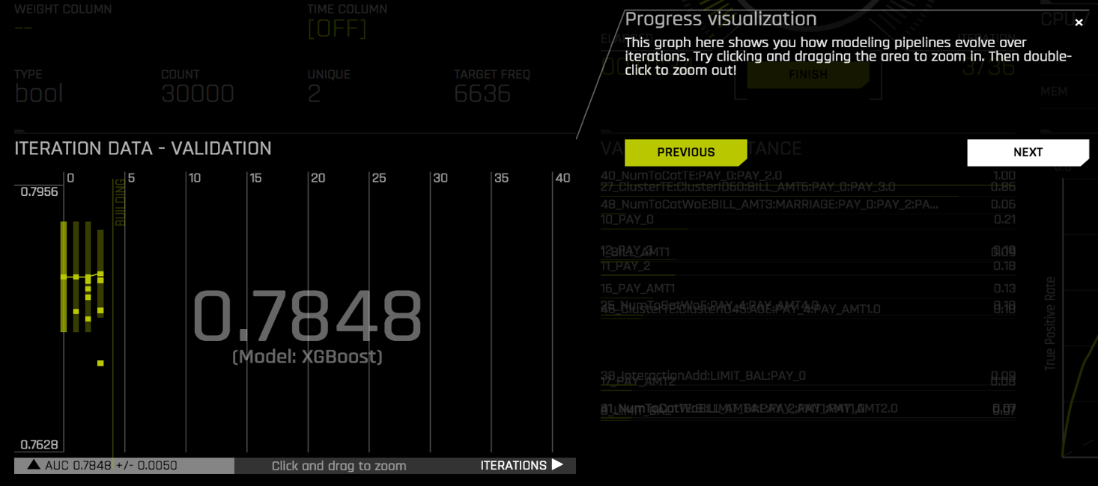

You can see the progress of the experiment in the center of the experiment dashboard as a % complete wheel (e.g. 20% COMPLETE) with current status (e.g. METRICS FINAL PIPELINE). The option to finish or terminate the run is also in this main view.

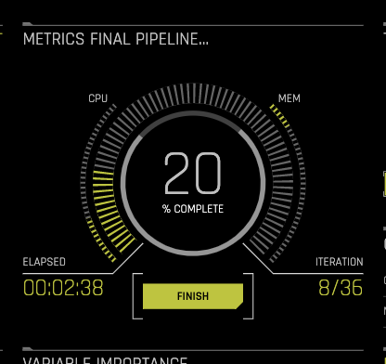

Congratulations! You’ve successfully followed the steps outlined in the tour to run your first experiment on your dataset.

**Hint:** you can find guidance for settings, explanations and additional details along the way in different ways:

* + - Look for text boxes like “ What do these settings mean?” on the right
    - Hover over blinking parameter (the blinking indicates logical next item to fill out)
    - Select the “ASSISTANT” and click on the green dots for info popups

Observe running experiment

From the experiment panel, you can observe additional details about the running model. You can see progress relative to number of iterations (e.g. 15 out of 74 scored models on 297 features) , a running update of variables ranked by importance.

If you click on “GPU USAGE” on the bottom right panel, you will see a graph of GPU utilization. Note that not all models leverage GPUs and “GPU ENABLED” need to be selected prior to launching the experiment. You’ll also note CPU and MEM graphs on the right.

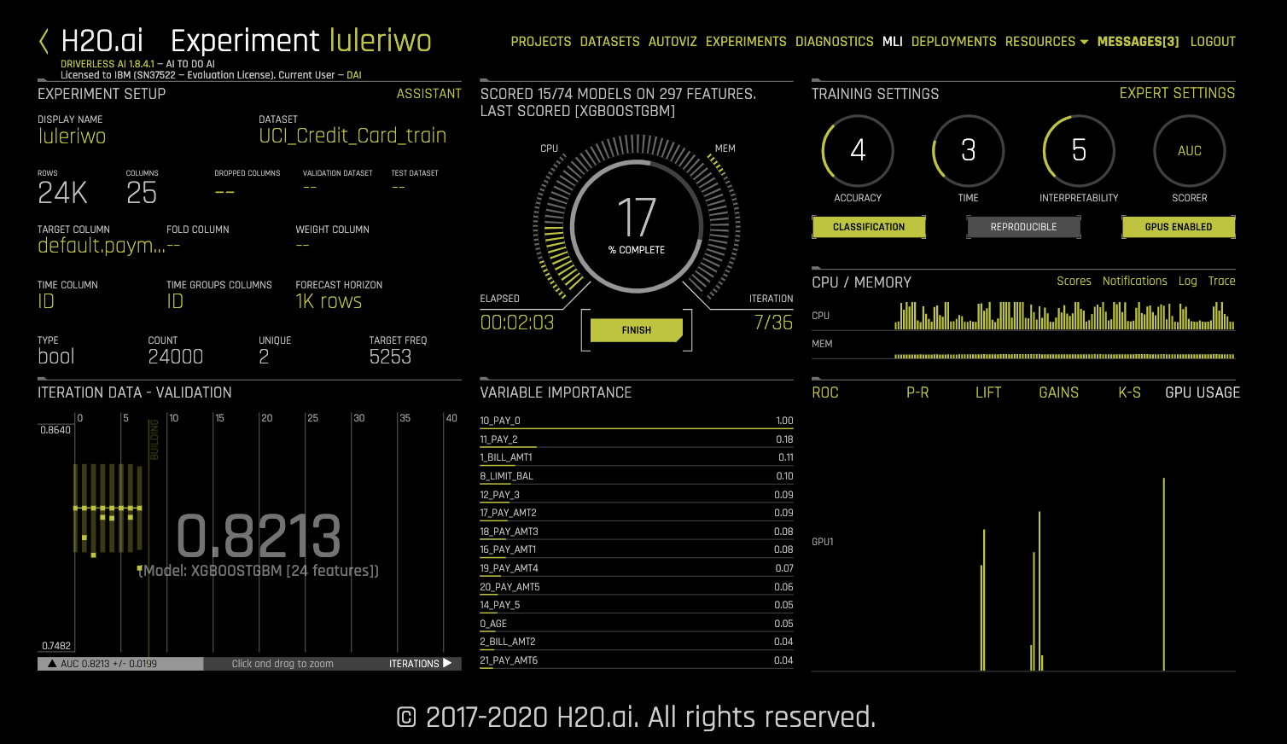

If you click “ROC” on the bottom right panel, and hover over a data point on the curve, you’ll see a confusion matrix of True Negative/False Positive/False Negative and True Positive predictions (TN, FP, FN, TP).

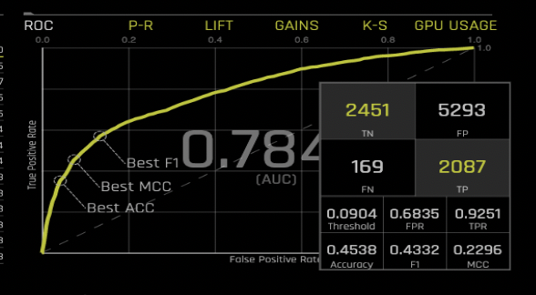

After your experiment completes “STATUS: COMPLETE”, you are now ready to take a closer look at you model and evaluate it for its capacity to produce your desired prediction outcomes.

## TEST MODEL

Run model against your test dataset

If you specified a test dataset during the experiment setup in the main experiment panel you can select “DOWNLOAD PREDICTIONS” from the center and pick TEST SET PREDICTIONS” to infer against your model and get predictions.

If not, choose “SCORE ON ANOTHER DATASET” and follow prompts to pick the test data created earlier from the split, select the columns to display and click “DONE” at the bottom of the panel to run inference. A final popup will prompt you to download the predictions.

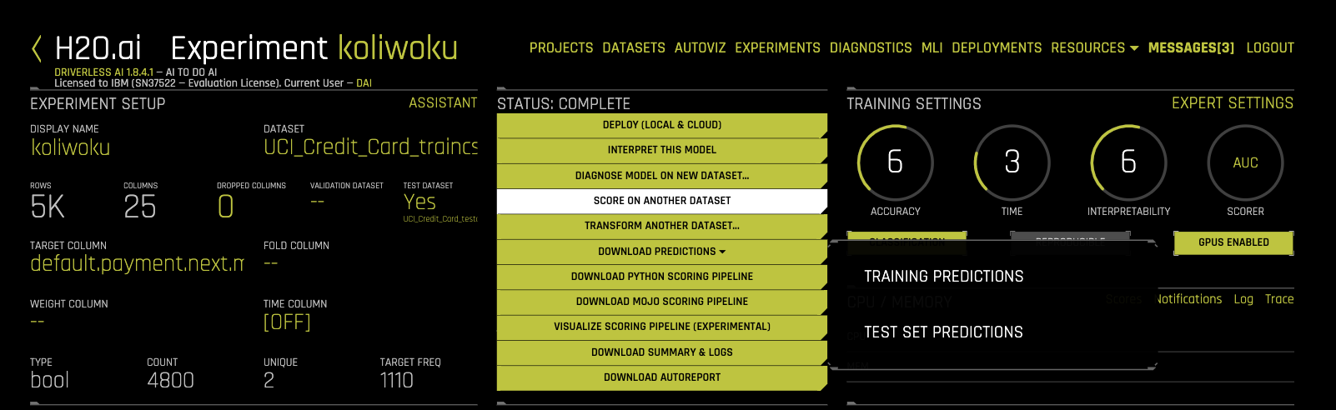

You will now find a csv file with columns named default_payment_next_month.0 and default_payment_next_month.1 and rows for each prediction on your PC or laptop. For example:

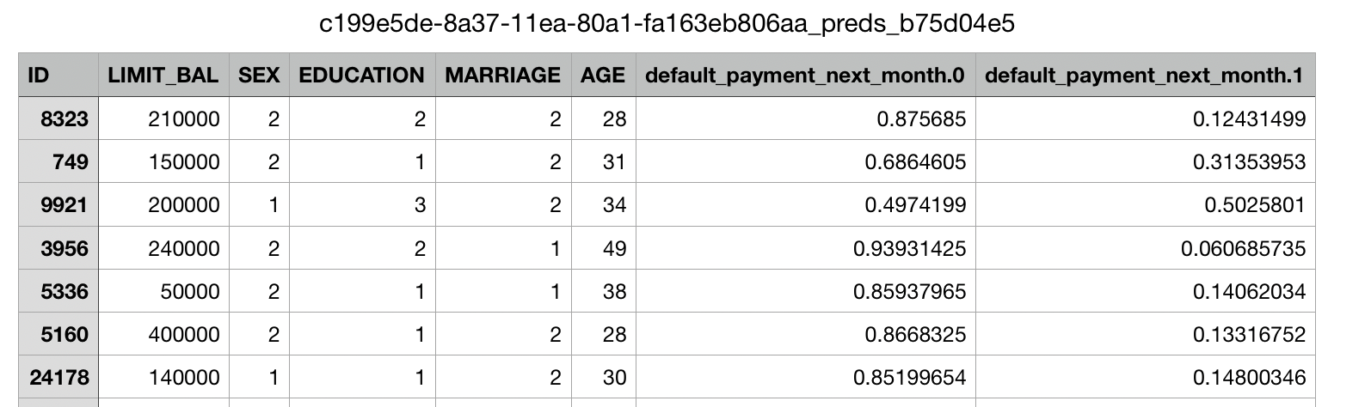

The location and default app to open your downloaded file depends on your PC and laptop setting.

## INTERPRET MODEL

Interpret experiment results

Driverless AI provides robust interpretability of machine learning models to explain modeling results in a human-readable format. In the Machine Learning Interpretability (MLI) view, Driverless AI employs a host of different techniques and methodologies for interpreting and explaining the results of its models. A number of charts are generated automatically (depending on experiment type), including K-LIME, Shapley, Variable Importance, Decision Tree Surrogate, Partial Dependence, Individual Conditional Expectation, Sensitivity Analysis, NLP Tokens, NLP LOCO, and more. Additionally, you can download a CSV of LIME and Shapley reasons codes from this view.

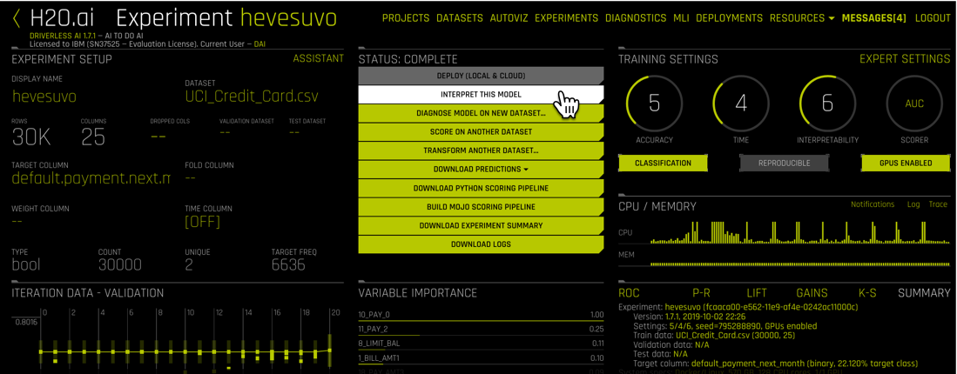

Select “INTERPRET THIS MODEL” from the experiment’s main interface under the “STATUS: COMPLETE” message. This may take a few minutes

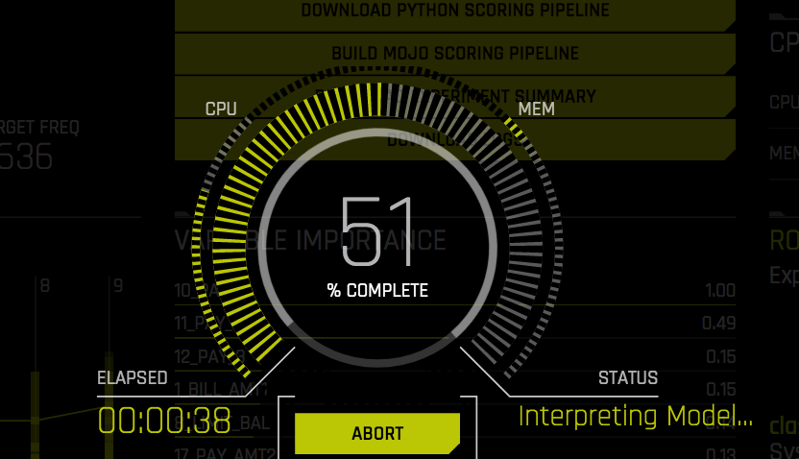

When complete, interpretation results are saved in the top menu “MLI” so you can refer to them later and you will be presented with a summary view. Scroll down to see the full set of information. What might you change?

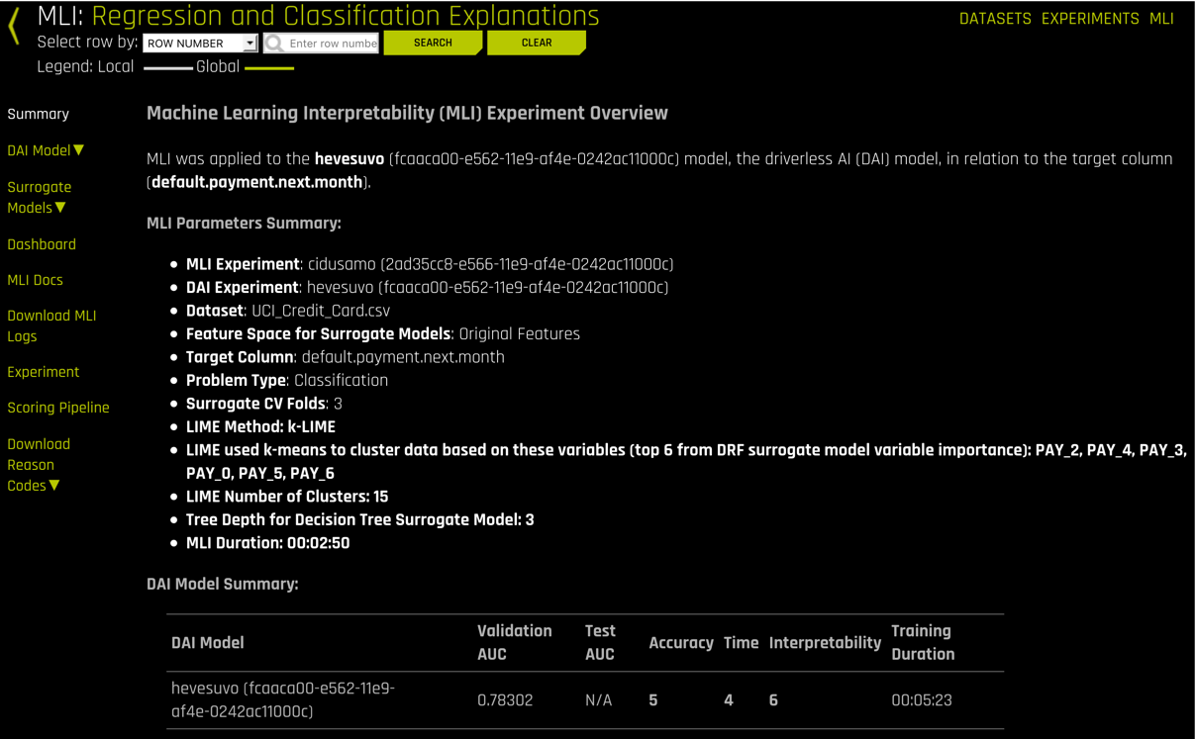

Let’s run through some of the menus on the left hand side for interpretation. We’ll interpret the model at a global level. Select DAI Model -> Feature Importance. This displays the weighting given by feature

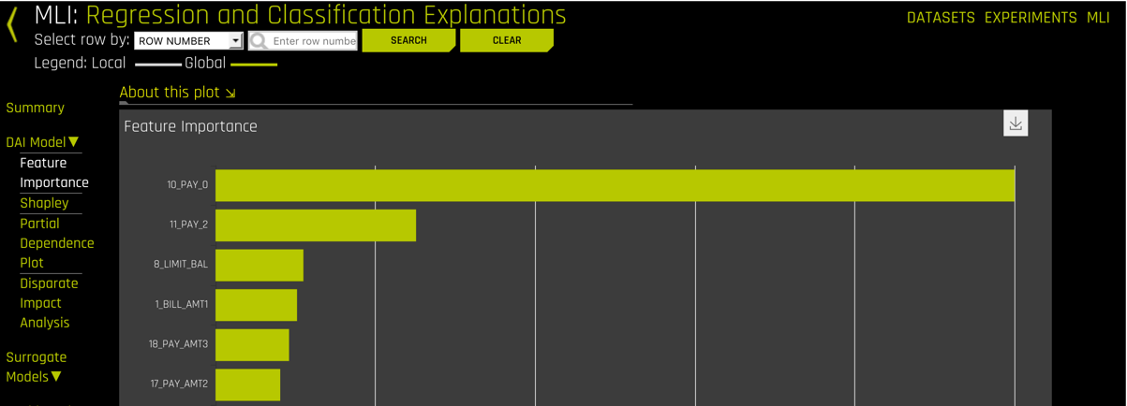

**Hint:** remember you can click on “About this plot” for more information on the purpose of all these plots.

Now select Surrogate Models -> KLIME. You can hover over the datapoints on this plot to see the difference between you model and other alternative models (KLIME in this case)

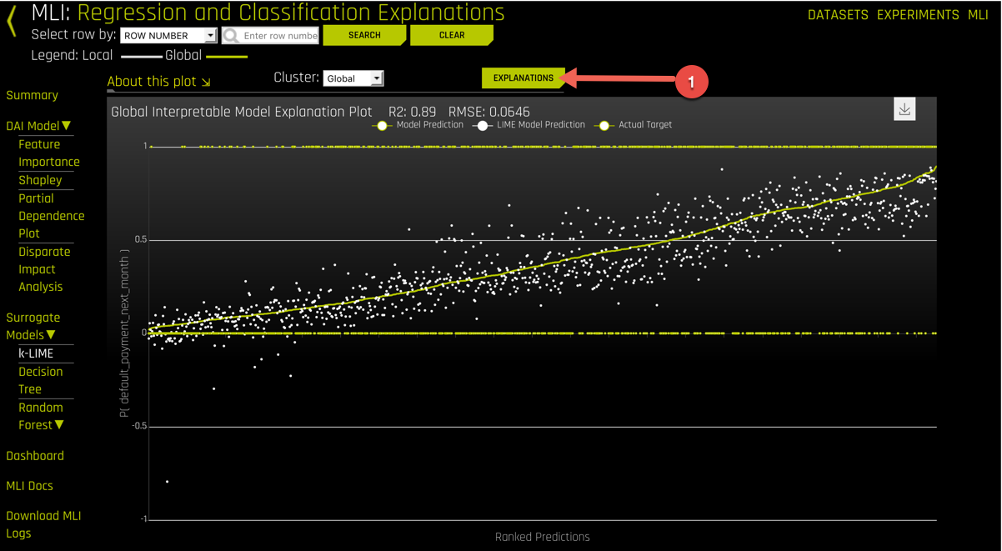

Selecting Explanation provides a view with the importance of various fields on model accuracy

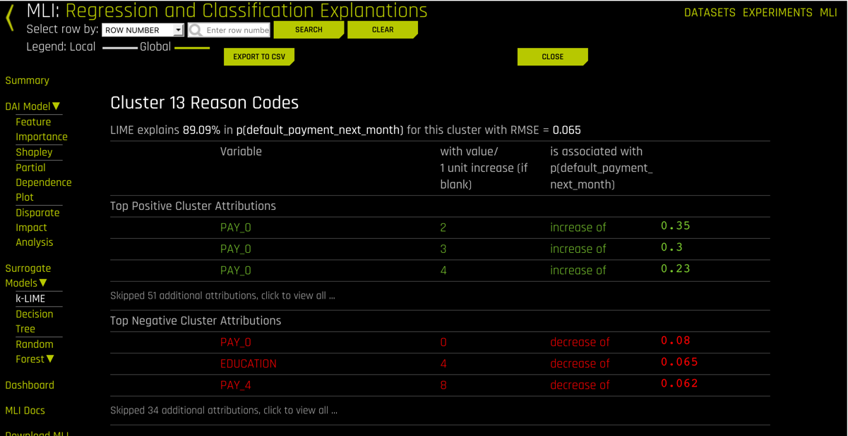

Next, Under Surrogate Models, select Decision Tree

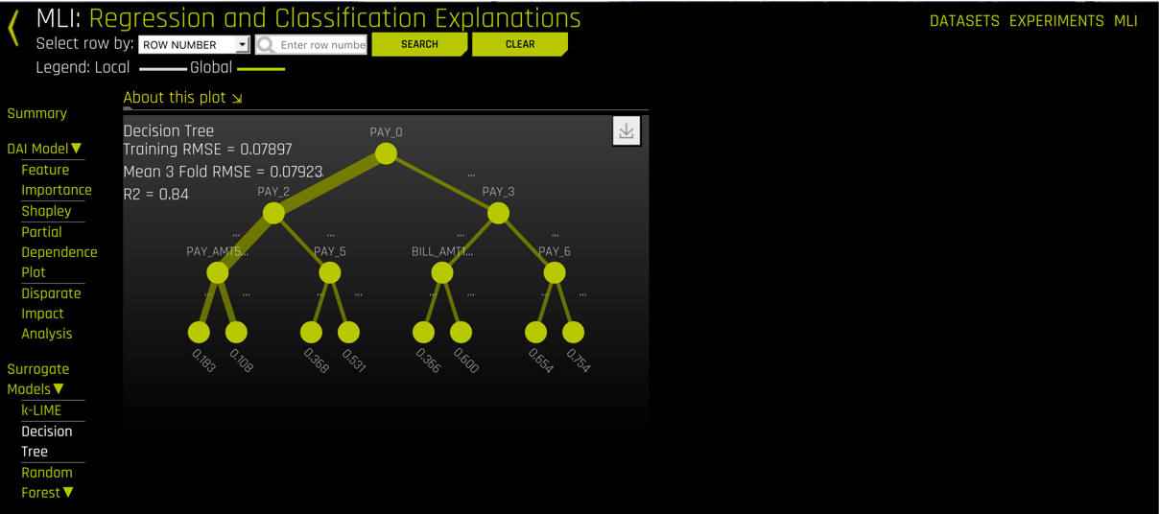

And Finally, under Surrogate Models, select Random Forest -> Feature Importance

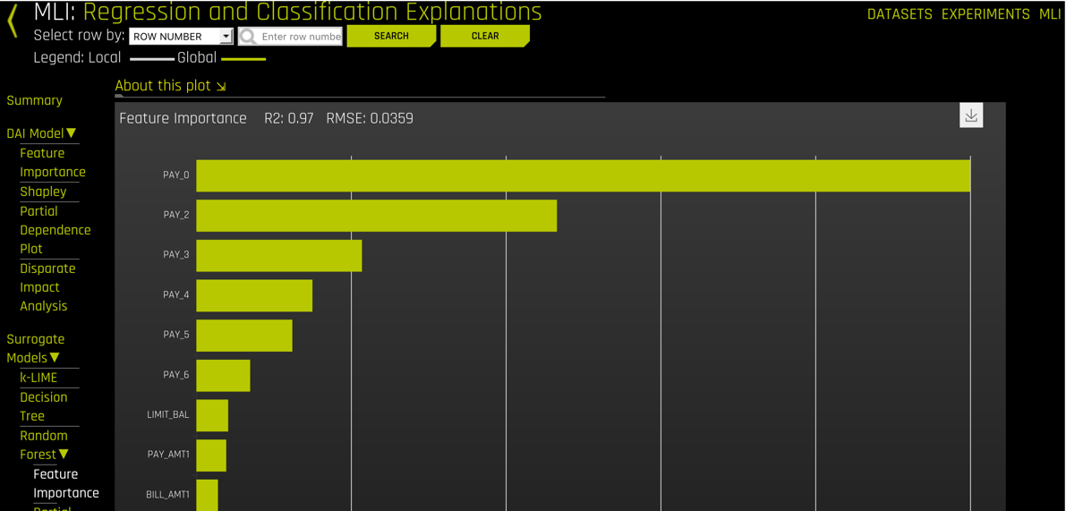

You can refine the information further. Select Random Forest -> Partial Dependence Plot. You can filter off of column data for example. Note that for most of these you can drill down to a single row by specifying row number or ID.

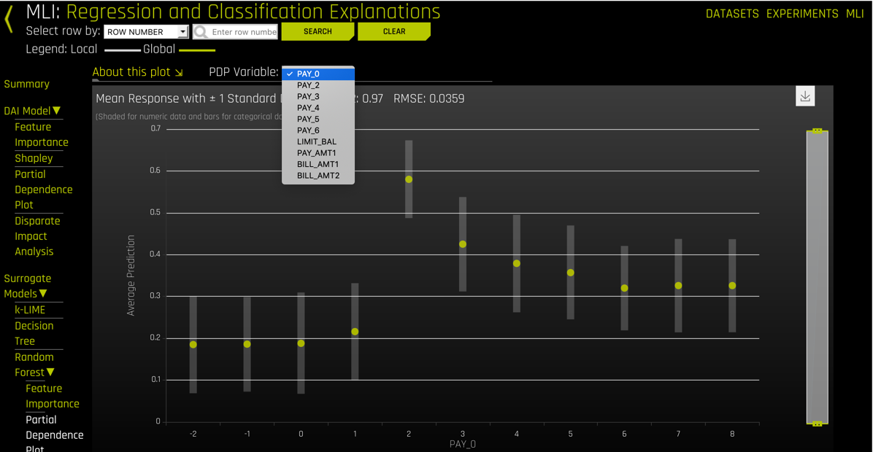

Or evaluate what the impact of a variable is on the predictions by leaving the variable out by selecting Random Forest -> LOCO

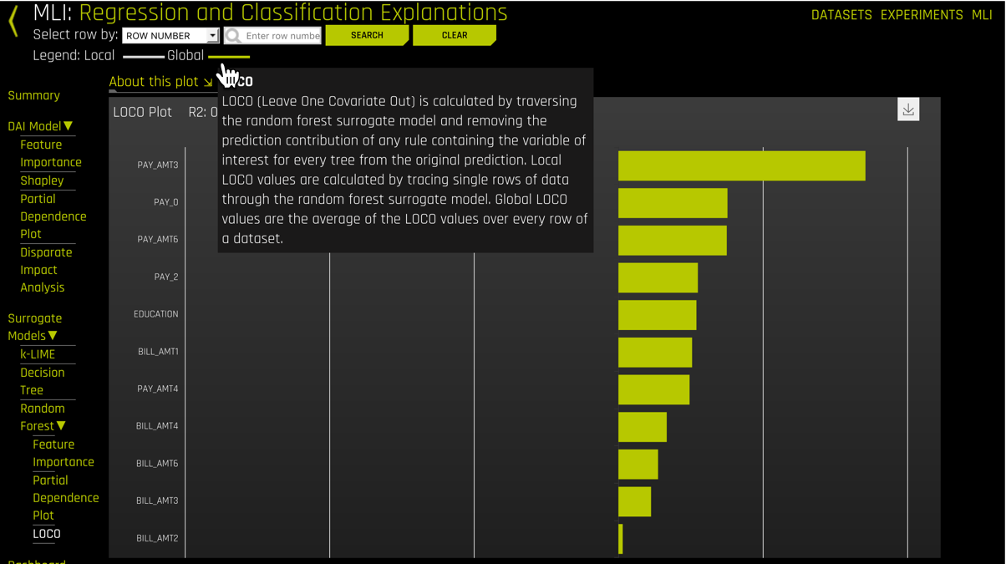

Select Dashboard to see all these views on the same page

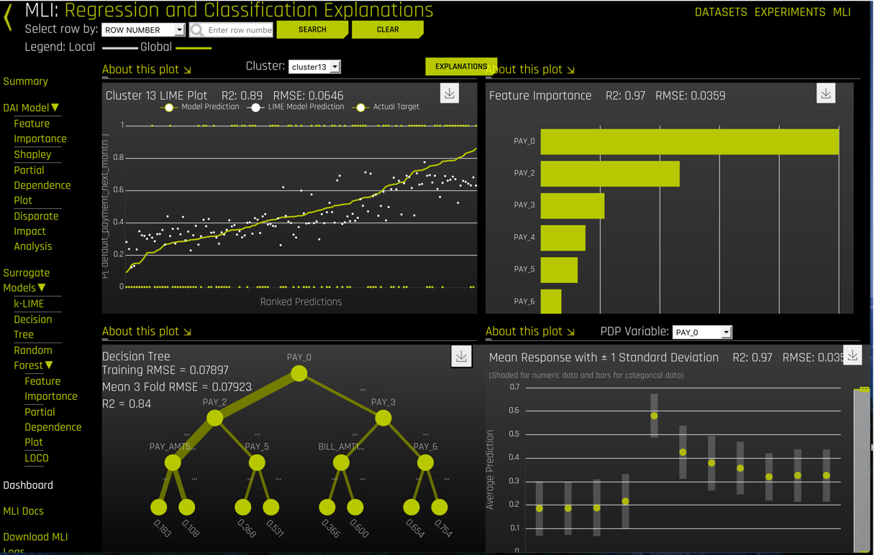

To generate a report and save information about this experiment, you can go back to the main interface for the experiment and select “DOWNLOAD AUTOREPORT”

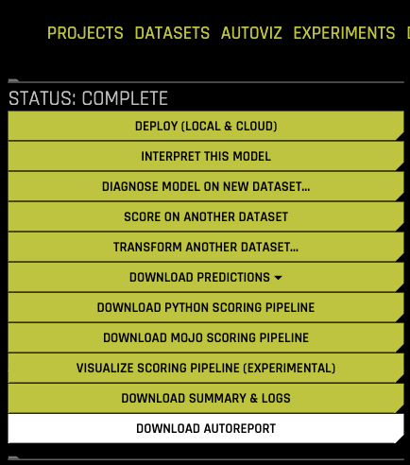

A word doc report will be downloaded onto your PC or laptop with a summary of the experiment. Open the downloaded file and look at the table of contents to see what information is reported for the experiment.

## EXPLORE NEW EXPERIMENTS

Adjust settings and repeat experiments

Go back to the “EXPERIMENTS” top menu page and run again with different values. Select previous experiment and select “RESTART FROM LAST CHECKPOINT” in actions pull down menu.

Try to create and launch a new experiment by changing some of the “TRAINING SETTINGS”.

* + - * What if you increase Accuracy?
      * What if you increase Time?
      * What is the effect of increasing Interpretability?

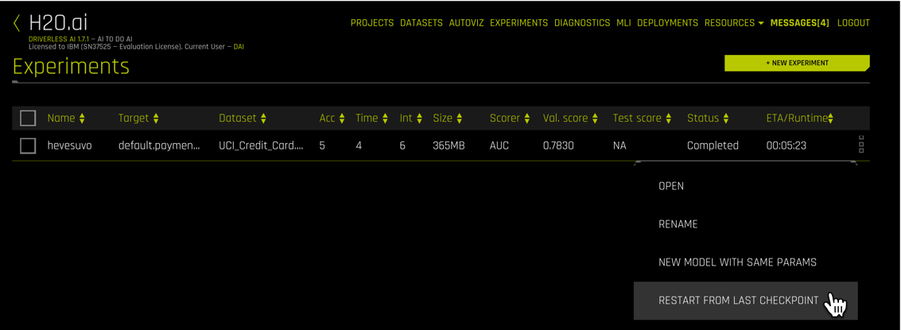

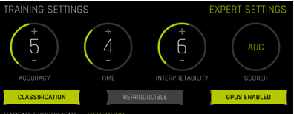

Note how one change updates multiple settings by looking at “What do these settings mean?” on the left hand side of the main interface. If interested, take a look at “EXPERT SETTINGS” to get a view of the strength of additional automated options available with Driverless AI - topics for an advanced lab.

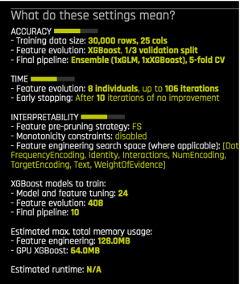

You can launch your experiment again after adjusting the dials or you view the “EXPERT SETTINGS” to make additional adjustments.

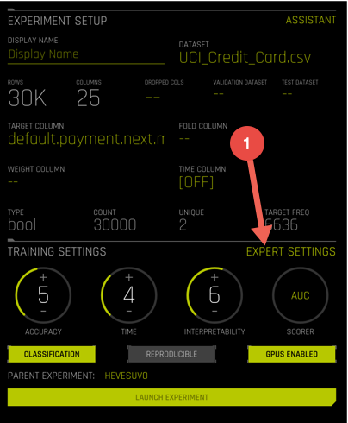

Explore additional settings available to Data Scientists and resident Experts.

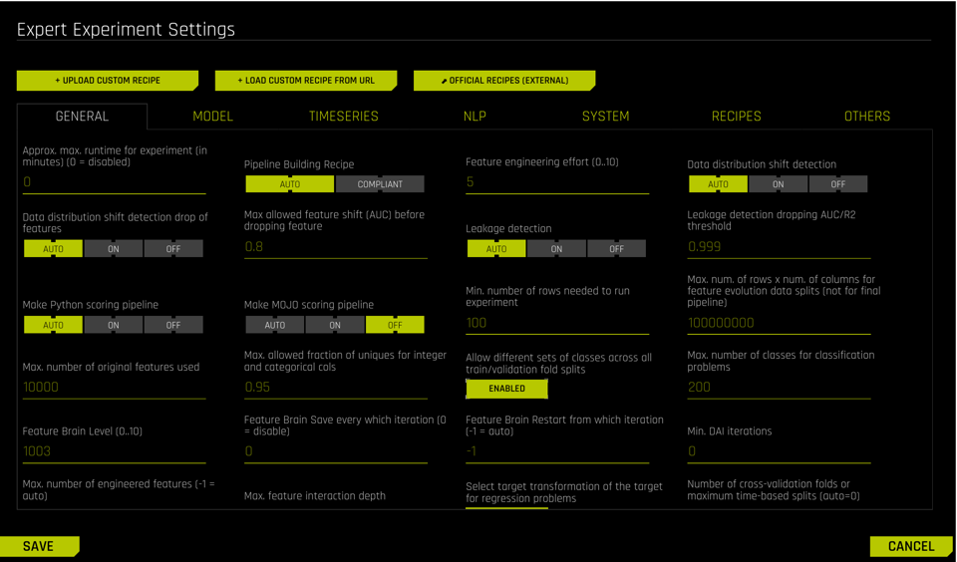

With new completed experiments, interpret the model again for additional insights.

Organize Datasets and Experiments

Select “PROJECTS” from top menu

Select “+ NEW PROJECT”

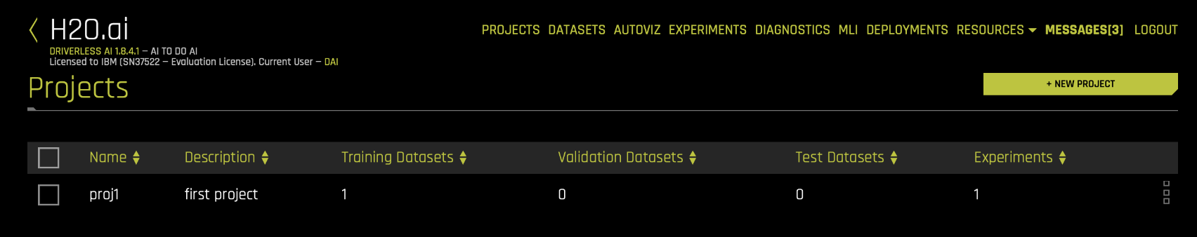

Fill out name and description for new project

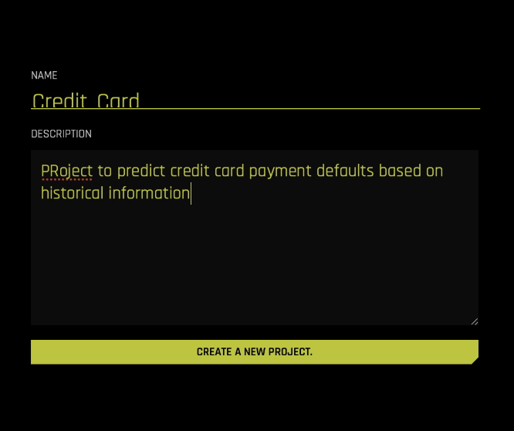

Link relevant datasets and experiments for you project

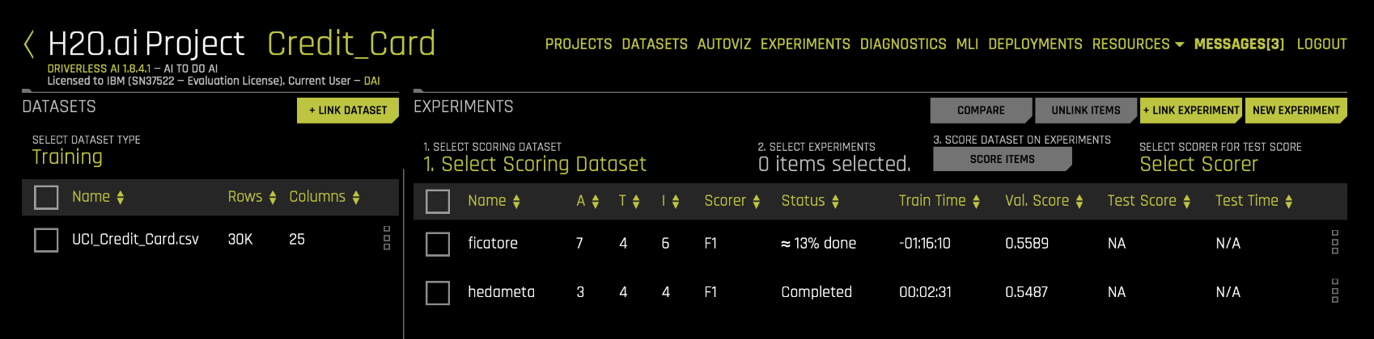

This provides a convenient all-in-one view of related datasets and experiments and at-a-glance status of different key descriptors and metrics. If 2 or more experiments are selected, they can be compared side by side

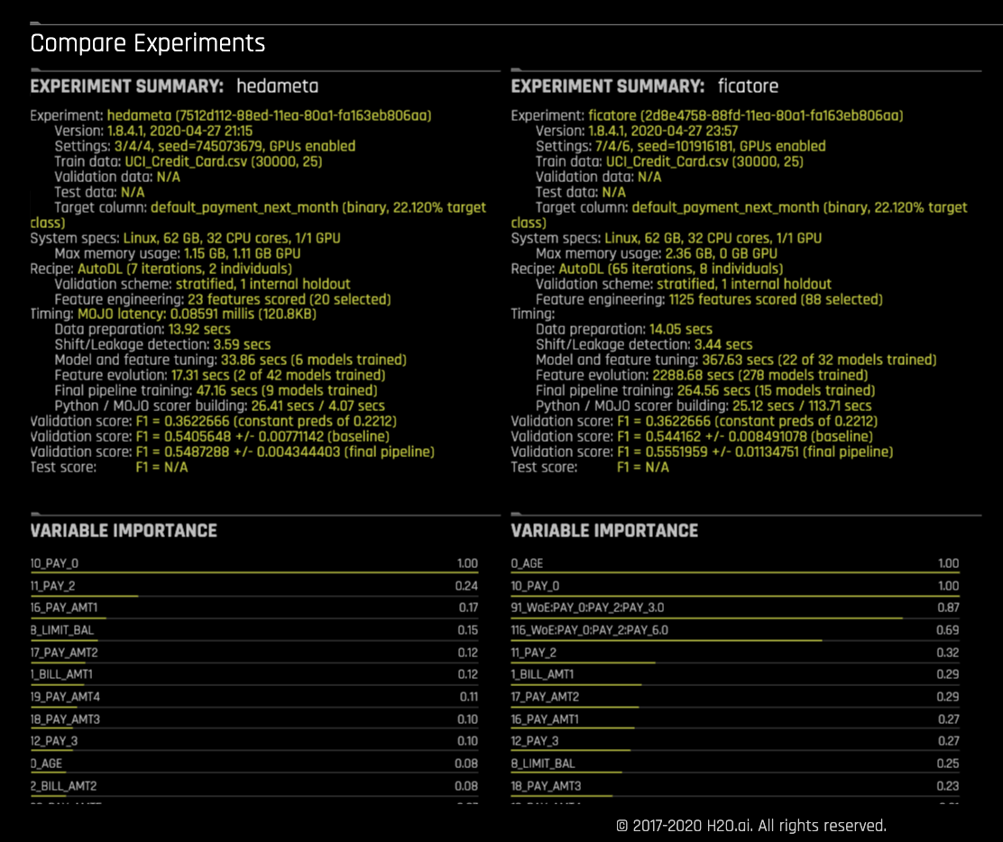

**Congratulations! You have just used H2O.ai Driverless AI on Power Systems to evaluate your models and gain insights from your data like a pro!**

# Using DAI to gain New Insights (optional)

In this section, we have provided some other use cases to explore. For each we’ve listed the complexity, the industry , a box link and source of the dataset and a target goal for the model and data analysis as well as some hints.

## Kidney Transplant Graft Rejection

Complexity

Simple

Industry

Healthcare/Medical Research

Dataset

Name: renal.csv

Size: 1,158 rows, 6 columns

Box link: <https://ibm.box.com/v/Renal-dataset>

Data source: <https://data.world/alexandrebohyn/graft-rejection>

Goal

A major concern in renal transplantation is graft rejection, and therefore it is of interest to understand which factors influence this rejection. For each of the 1158 patients included in the dataset, it was recorded whether there were symptoms of graft rejection, 3 months after the transplantation. Moreover, information of the patient at baseline is included, namely, the age, gender, cardio-vascular status and hematocrit level (proportion of red blood cells in blood) of the patient (just) before the transplant.

Build a model to predict graft rejection, interpret the model accuracy and explore the most important pre-transplant factor.

Is the best model trained with this dataset good enough in real life?

Hints

Step through the lab as described

Select “reject” as the “TARGET COLUMN”

Answer is NO so proceed without high expectations and no pressure to get it right!

## Number of COVID-19 cases

Complexity

Advanced

Industry

Healthcare/Epidemiology

Dataset

Name: HOPKINS_CLEANED_Apr29.csv

Size: 25,872 rows, 22 columns

Box link: <https://ibm.box.com/v/Covid-19-dataset>

Data source: <https://github.com/CSSEGISandData/COVID-19>

Goal

The Covid-19 pandemic has generated significant interest in understanding the data behind patient cases to determine trends. These trends have been used to understand risk, define policies and predict future new cases recovery and death rates. Disparate data has been coming in from various countries reporting new cases and death daily. This data can be analyzed from an individual country or a finer grained regional perspective or across multiple geographic groupings. The data can also be looked at based on absolute dates or normalized (e.g. day 1 = first new case reported). What to predict can also vary (e.g. forecasting new cases ). The datasets we are providing to explore already has some of these aggregated sources of information. The primary dataset “HOPKINS_CLEANED_Apr29.csv” is a very large dataset with too much information. Your first task will be to explore and visualize it and think about what insights might be interesting to model.

We’ll share other datasets that are subsets of the first with less data and more relevant derived columns to answer a more specific question: Given data from day 1 to day N, can we predict the number of new cases for the following 3 days?

Build a time-series model to predict new cases, interpret the model accuracy and explore the most important new case factors.

Did you find a dataset and model to train that provided real life insights?

Hints

The challenge here may be too much data, so the first step will be to simplify the data

Second challenge will be to pick a “TARGET COLUMN” well (e.g. “daily new cases”)

Third challenge will be to set up a Time-Series experiment (this is an advanced topic –

start with “TIME” on Auto)

Finally, picking the right scorer (start with default suggestion) for your experiment

The intent is not to do a better job than some of the dashboards that many have built on the web but to get of feel of the advanced features H2O.ai Driverless AI brings.

This blog from H2O.ai has some approached documented:

<https://www.h2o.ai/blog/modelling-currently-infected-cases-of-covid-19-using-h2o-driverless-ai/>

# Additional Resources

Additional H2O.ai assets are available for IBMers and Business Partners:

* **H2O.ai Driverless AI key assets on Seismic:**

<https://ibm.seismic.com/Link/Content/DCXoozUIFfBUiimKC5EMVH4w>

* **H2O.ai DAI tutorials on GitHub:**

<https://h2oai.github.io/tutorials/>

# Appendix A: Requesting an H2O.ai Driverless AI Server from the CECC

People outside of IBM wanting to try H2O.ai Driverless AI can request access to a trial environment by making a request to aicoc@us.ibm.com. At one point you will be given the opportunity to sign up for access.

IBMers and Business Partners can request access to an H2O.ai Driverless environment through the Client Experience Center Cloud (CECC). The steps for requesting a server and accessing the provisioned server are included below.

**Provision H2O.ai Driverless AI Instance through the CECC Portal**

1. Here are the steps to Follow – click on this link: <http://ibm.biz/cecc-portal>.
2. Login with your IBM id and review / accept the usage agreement.
3. From the left sidebar, select the **H2O.ai** checkbox.

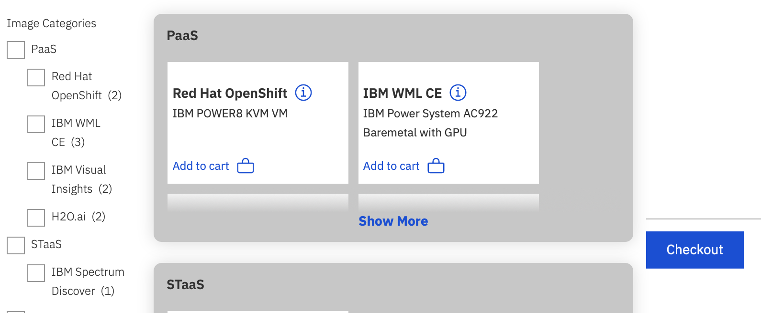

Select the **H2O.ai (IBM POWER9 KVM VM with GPU)** tile by clicking the **Add to cart** link within it. You can also select POWER8 if availability is an issue or you don’t need high performance levels (light demo for e.g.). Note that there is also are also tiles with CECC to request a bare metal environment, but this is typically reserved for Proofs of Concept and client opportunities, and not for education purposes.

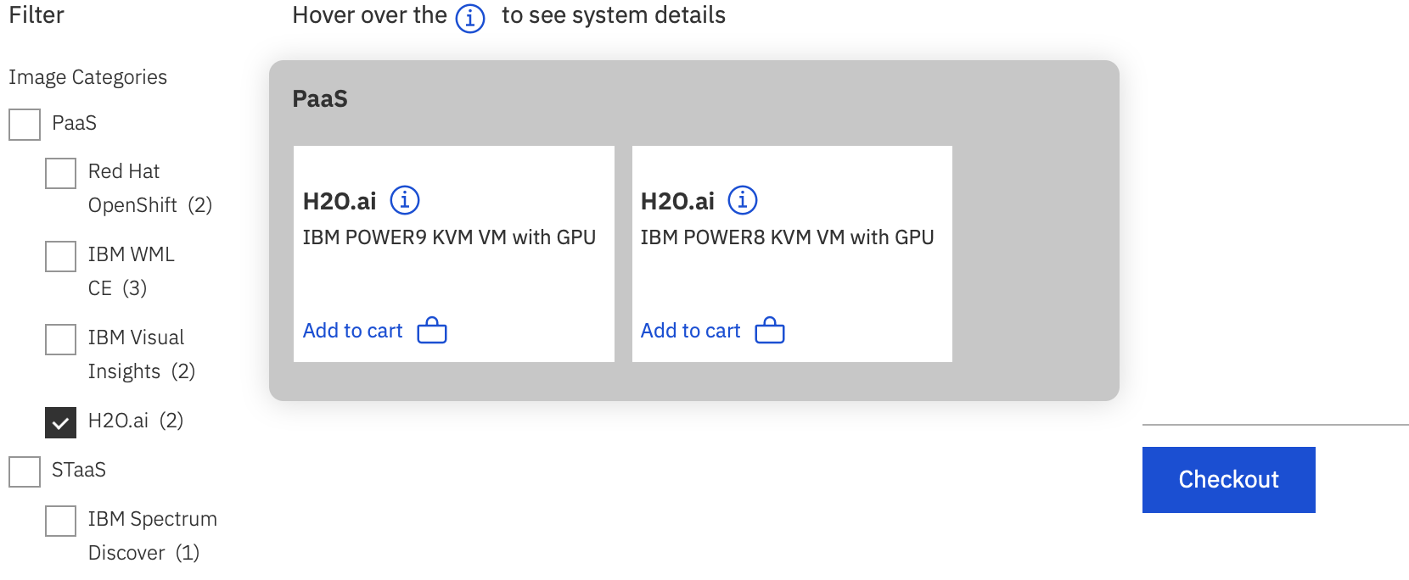

Leave all the default options and click the **Add** button.

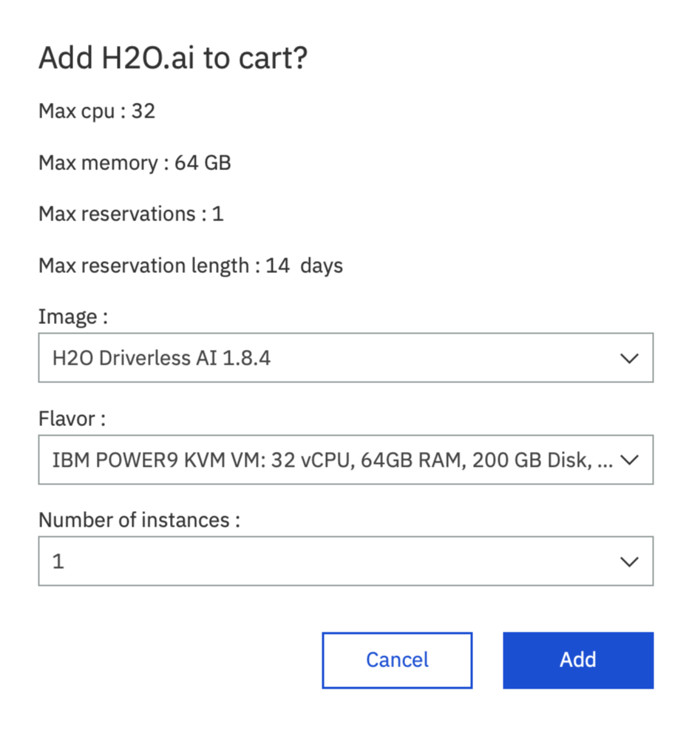

Click the **Checkout** button.

Fill out the project details and click the **Create Project** button. A few things to note:

* + Be sure to set a descriptive name and specify **“Education / Training”** in the **Used for** section.
  + If you are requesting immediate access (versus a time in the future) then provisioning may take upwards of two or more hours.
  + Please consider specifying a realistic timeframe that is courteous to other users of the CECC. For instance, if you’re only planning to go through a lab then you may only need it for a couple of days.

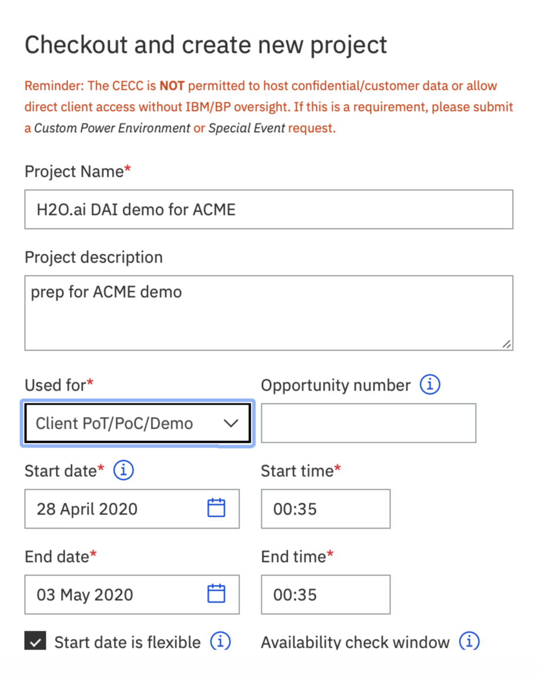

Once submitted successfully, the following message should be displayed. Click the **Ok** button to dismiss.

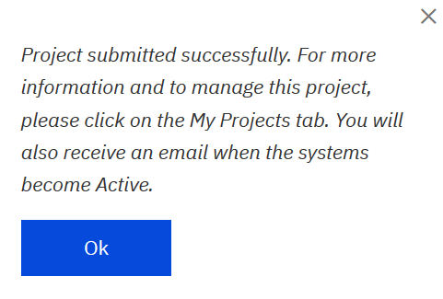

**Connecting to the Provisioned Visual Insights Server**

Navigate to the **My Projects** tab in the top navigation bar.

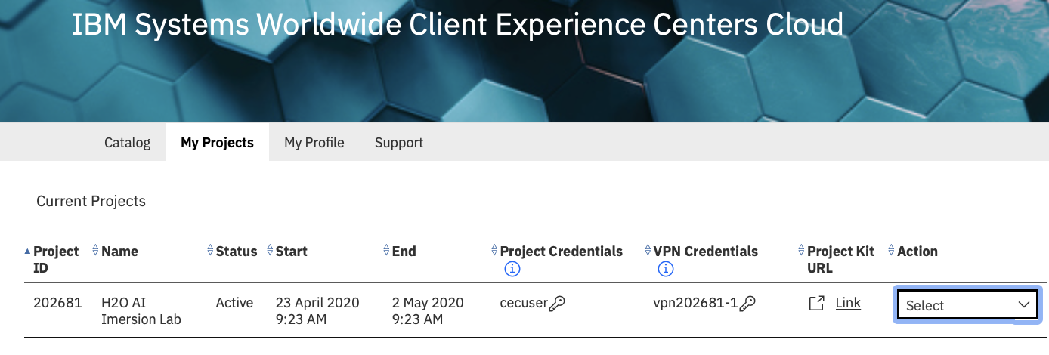

Click the **Project Kit URL** link associated with your request.

The Project Kit will look like this:

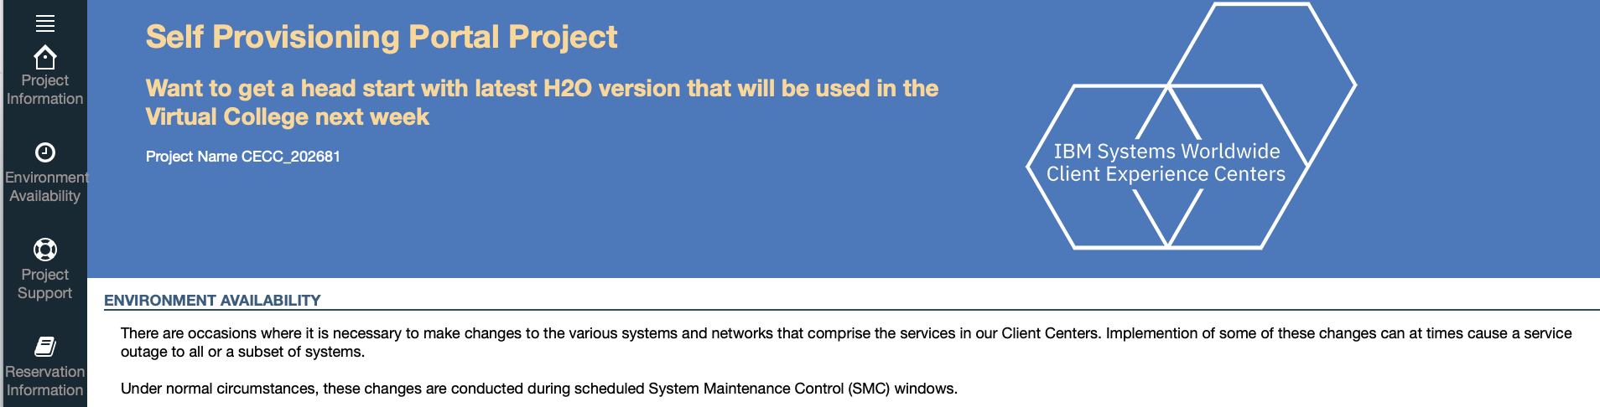

If you are not on the IBM Intranet then you need to VPN in to be able to access your Visual Insights instance. Scroll down to the bottom of the Project Kit and follow the instructions on connecting to the VPN.

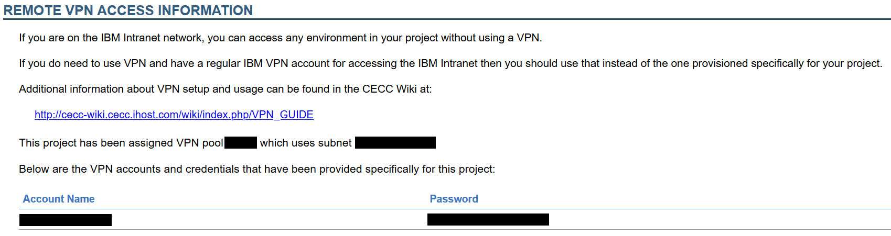

Go to the **Reservation Information** section and click the link provided to connect to the H2O.ai Driverless AI web interface.

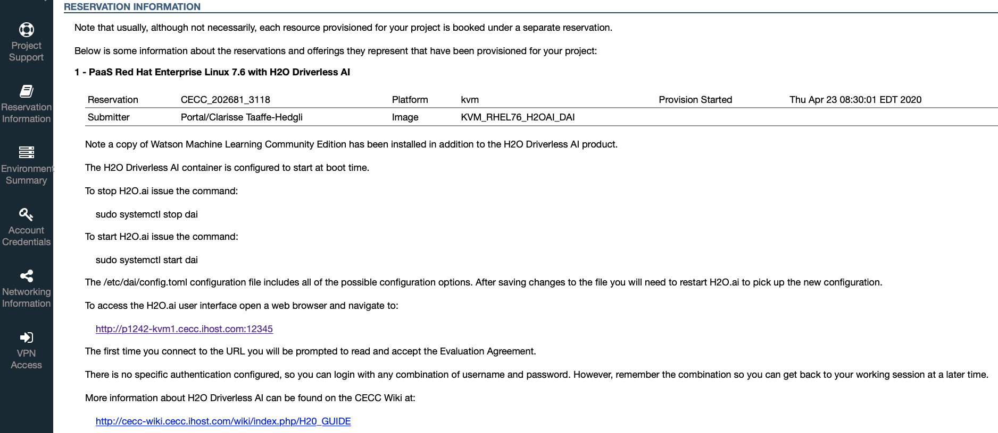

Enter the following information for the web portal login and then click the **Login** button:

* + Username: dai
  + Password: dai

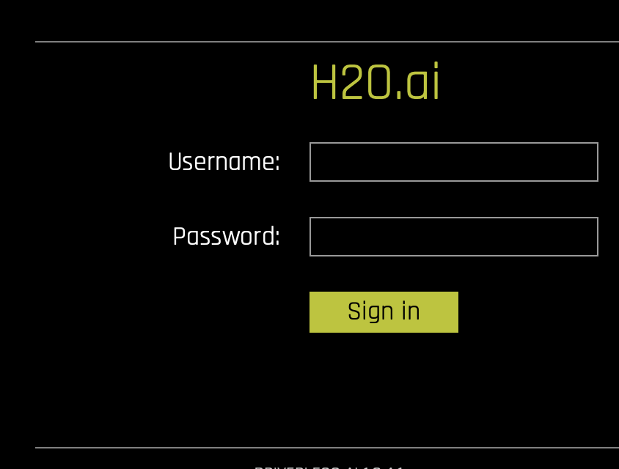

Once you have successfully logged in you will be navigated to the main screen from where you can get started with H2O.ai

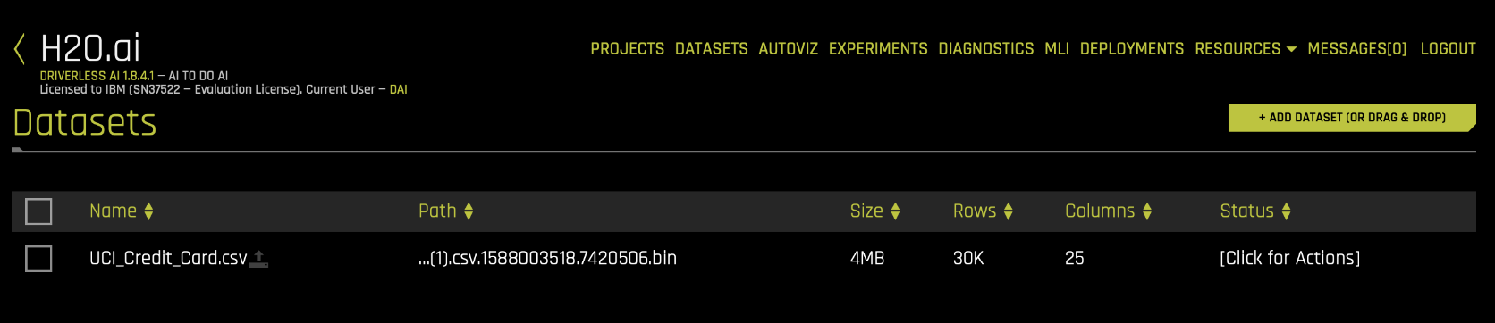

**Deleting Your H2O.ai Instance**

The environment will be active until the end date specified for the project, at which point it will be automatically deleted. However, if you are finished with it prior to this date then please be courteous and manually delete it so that the resources can be used by others. You can do this by choosing **End** from the **Action** list for your project.

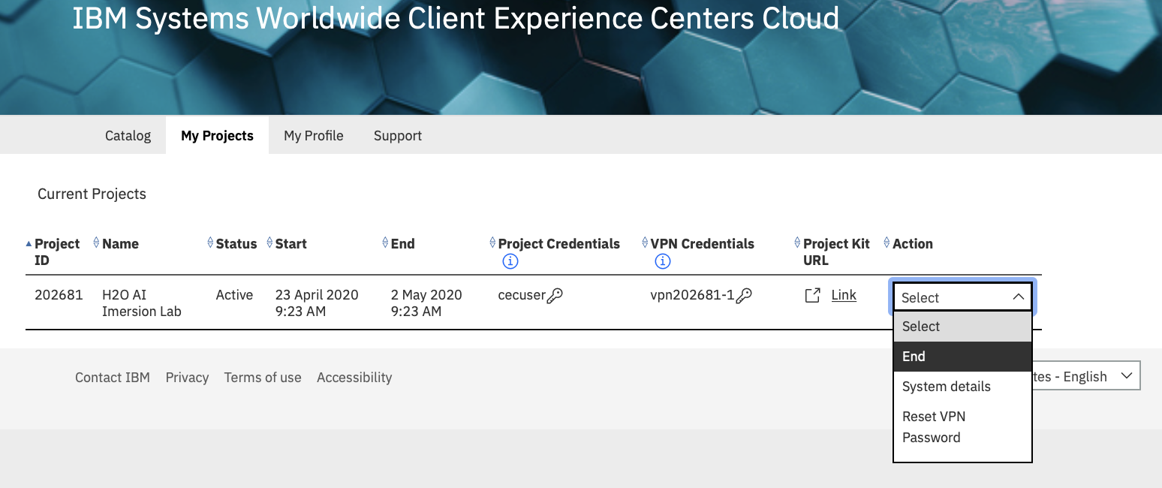

*(Credit: Thomas Famularo)*